CprE 288 Fall 2024 – Homework 1 (50 points)
Due Sun. September 1 (on Canvas by midnight: 11:59pm)
Notes:
- Homework must be typed and submitted as a PDF or Word Document (i.e. .doc or .docx) only.
- If collaborating with others, you must document who you collaborate with, and specify in what way you collaborated (see last page of homework assignment), review the homework policy section of the syllabus: http://class.ece.iastate.edu/cpre288/syllabus.asp for further details.
- Review University policy relating to the integrity of scholarship. See (“Academic Dishonesty”): http://catalog.iastate.edu/academic_conduct/#academicdishonestytext
- Late homework is accepted within two days from the due date. Late penalty is 10% per day. Note: On Exam weeks no late homework is accepted.
- Note: Code that will not compile is a typo. Answering a question as “will not compile” will be marked incorrect. Contact the Professor if you think you have found a typo.

Note: Unless otherwise specified, all problems assume the TM4C123 is being used

Question 1:
The purpose of this question is to refresh your understanding of numeric representation from the prerequisite courses.
Complete the table below. Assume ASCII encoding of characters, and a 2’s complement encoding of negative numbers. Recall what you have learned about 2’s complement encoding from other courses. When representing a number in hexadecimal or binary, use the proper number of digits for the TM4C123 architecture (depends on type of variable). The first row has been completed for you.
 | Value of x
 | x (decimal) | x (hex) | x (binary)
signed char x = 60; | 60 | 0x3c | 0b00111100
unsigned char x = 'S';
unsigned char x = '8';
short x = 0xEECE;
signed char x = 0b00111001;
unsigned short x = 0x2050 + 0x2041;
signed char x = 0x8 + 4;
signed char x = 0x68 / 8;
signed short x = -1;
signed char x = 20;
signed char x = -128;

Question 2 Embedded Applications:
a) Give four appliances/products, with an embedded-processor, you use in daily life

b) Find an article on an embedded system application you are interested.

i) Properly cite the articles that you use to obtain your information to receive credit. For proper formatting, see the IEEE citation reference manual:
https://ieee-dataport.org/sites/default/files/analysis/27/IEEE%20Citation%20Guidelines.pdf.
Note, while Wikipedia is discouraged for citations used within published academic papers, it can be useful for obtaining an overview on a topic. If you use a Wikipedia article, then use this guide for properly citing your “source”: http://www.wikihow.com/Cite-a-Wikipedia-Article-in-MLA-Format

ii) Give a brief description of the application.

iii) What needs does the User(s) have?

iv) How does the application help meet the Users’ needs?

Question 3: Review Basics
a. Fill in the units?
ms 10⁻³ seconds (answer given)
10⁻⁶ seconds
10⁻⁹ seconds
2¹⁰ Bytes
2²⁰ Bytes
2³⁰ Bytes
10³ Hz
10⁶ Hz

b. Period or frequency
i) What is the period of a 2 MHz clock?

ii) What is the frequency of a clock with a 1 ns period?

iii) How many positive edges of a 4 MHz clock will occur in 4 ms?

c. Digital logic
i) Briefly describe how a multiplexer works?

ii) What is the minimum number of select bits (wires) need for the multiplexer below? Why?
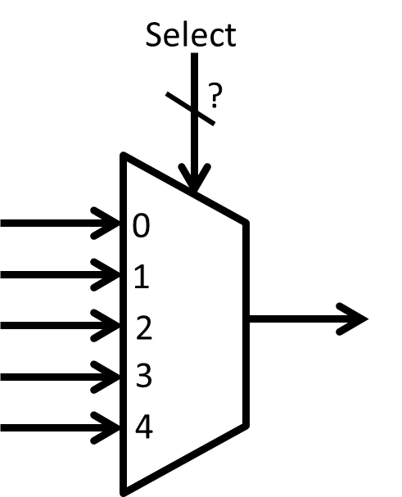

iii) A clock signal is given as an input to an AND gate, as shown below. What constant value needs to be placed on the other input to allow the clock signal to propagate through the AND gate? Why?
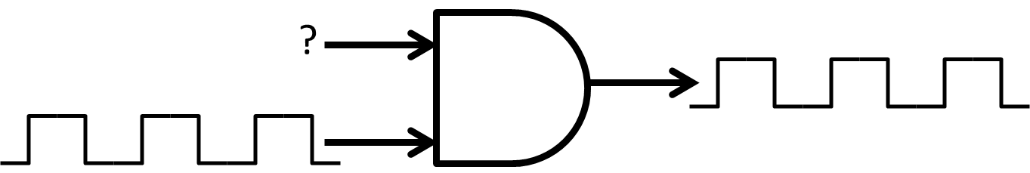

Question 4: Memory Allocation (Reminder assume an TM4C123 is the target hardware unless otherwise specified)

For each declaration indicate how many bytes will be allocated in memory

a) int apple;

b) long my_oranges[100];

c) float sensor_readings[100];

d) unsigned short class_grades[140];

e) unsigned int scan_data[10][100];

Question 5: Internal Components of Microcontrollers

Based on the lab discussion during the first week of class, and any other readings, answer the following questions about microcontrollers:

a) List the main 6 components that make up the inside of a Microcontroller chip. Give a short description of your understanding of the purpose (i.e. job) of each component.

b) Pick two of the components, and for each give a question you would ask to try to learn more about the components you chose.

Collaboration Documentation
List the people (First and Last name) you collaborated with: .
For each collaborator, describe the manner in which you collaborated:

1)
2)
3)

