CprE 288 Fall 2024 – Homework 10
Due Sunday November 10. (on Canvas 11:59pm)
Notes:
- Homework must be typed and submitted as a PDF or Word Document (i.e. .doc or .docx) only.
- If collaborating with others, you must document who you collaborate with, and specify in what way you collaborated (see last page of homework assignment), review the homework policy section of the syllabus: http://class.ece.iastate.edu/cpre288/syllabus.asp for further details.
- Review University policy relating to the integrity of scholarship. See (“Academic Dishonesty”): http://catalog.iastate.edu/academic_conduct/#academicdishonestytext
- Late homework is accepted within two days from the due date. Late penalty is 10% per day. Exception: on Exam weeks no late homework accepted
- Note: Code that will not compile is a typo. Answering a question as “will not compile” will be marked incorrect. Contact the Professor if you think you have found a typo.
- Note: You are not allowed to use any MACROs in your code, except for register names.
- Example: You will lose points for: GPIO_PORTA_DEN_R = GPIO_PORTA_DEN_R | PIN1
- Must use: GPIO_PORTA_DEN_R = GPIO_PORTA_DEN_R | 0b0000_0010; // or 0x02

Note: Unless otherwise specified, all problems assume the TM4C123 is being used

Timer Readings:
Datasheet Reading Guide: General-Purpose Timers: Chapter 11 (~15 pages on functionality)
a) Skip the following
i) Skip: Section 11.3.2.2: Real-Time Clock Timer Mode
ii) Skip: Section 11.3.2.3: Input Edge-Count Mode
iii) Skip: Sections 11.3.3 – 11.3.5: Wait-for-Trigger Mode, Synchronizing GP Timer Blocks, DMA
iv) Skip: Section 11.3.7: Accessing Concatenated 32/64-Bit Wide GPTM Register Values
b) Important registers:
i) Register 1: GPTM Configuration (GPTMCFG): TIMER#_CFG_R
ii) Register 2,3: GPTM Timer A(B) Mode(GPTMTA(B)MR): TIMER#_TA(B)MR_R
iii) Register 4: GPTM Control (GPTMCTL) : TIMER#_CTL_R
iv) Register 6: GPTM Interrupt Mask (GPTMIMR) : TIMER#_IMR_R
v) Register 7: GPTM Raw Interrupt Status (GPTMRIS): TIMER#_RIS_R
vi) Register 8: GPTM Masked Interrupt Status (GPTMMIS) : TIMER#_MIS_R
vii) Register 9: GPTM Interrupt Clear (GPTMICR) : TIMER#_ICR_R
viii) Register 10,11: GPTM Timer A(B) Interval Load (GPTMTA(B)ILR) : TIMER#_TA(B)ILR_R
ix) Register 12,13:GPTM Timer A(B) Match(GPTMTA(B)MATCHR): TIMER#_TA(B)MATCHR_R
x) Register 14,15: GPTM Timer A(B) Prescale (GPTMTA(B)PR) : TIMER#_TA(B)PR_R
xi) Register 16,17: GPTM TimerA Prescale Match (GPTMTAPMR) : TIMER#_TA(B)PMR_R
xii) Register 18,19: GPTM Timer A (GPTMTAR) : TIMER#_TA(B)R_R
xiii) Register 20, 21: GPTM Timer A(B) Value (GPTMTAV) : TIMER0_TA(B)V_R
xiv) Sec 5.5, page 338: Register 59: GP Timer Run Mode Clk Gating Control: SYSCTL_RCGCTIMER_R
c) Textbook 9.1 – 9.2: a good supplement to the Datasheet, as needed (~30pages)
i) Note: Figure 9.1 is useful
ii) Note: Figure 9.10 is a useful Periodic Timer code example
iii) Note: Figure 9.14 is a useful Input-Edge Time Mode (Input capture) code example.
iv) Note: There 9.17 is a useful PMW Mode code example.

Question 1: Don’t Go into the Light!

Complete the program below to have a robot move away from a light source. The robot has two wheels, similar to the robot used in lab, and has a light sensor on each side. See figure.

Motor Control: Assume that you are programming Timer 1 module A (for left motor) and Timer1 module B (for right motor) to generate PWM waveforms to control the speed of each wheel’s motor (note, connect Timer 1 to Port B). The speed of the motor is proportional to the percentage of time the PWM signal is high (i.e. PWM duty cycle).

Note: Your PWM wave must have a period of 1ms. Note the system clock is 16 MHz.

Light Sensors: The light sensors are connected to Channel 1 (left sensor) and 9 (right sensor) of the ADC as single channel inputs (i.e. not differential)

Robot behavior: The Robot should move away from the light in the following way. Where “Speed of motor” is the fraction of the motor’s maximum speed.
- Speed of left motor = Intensity of left sensor / (Intensity of left sensor + Intensity of right sensor)
- Speed of right motor = Intensity of right sensor / (Intensity of left sensor + Intensity of right sensor)

Note: You are not allowed to use any MACROs in your code, except for register names.
- Example: You will lose points for: GPIO_PORTA_DEN_R = GPIO_PORTA_DEN_R | PIN1
- Must use: GPIO_PORTA_DEN_R = GPIO_PORTA_DEN_R | 0b0000_0010; // or 0x02

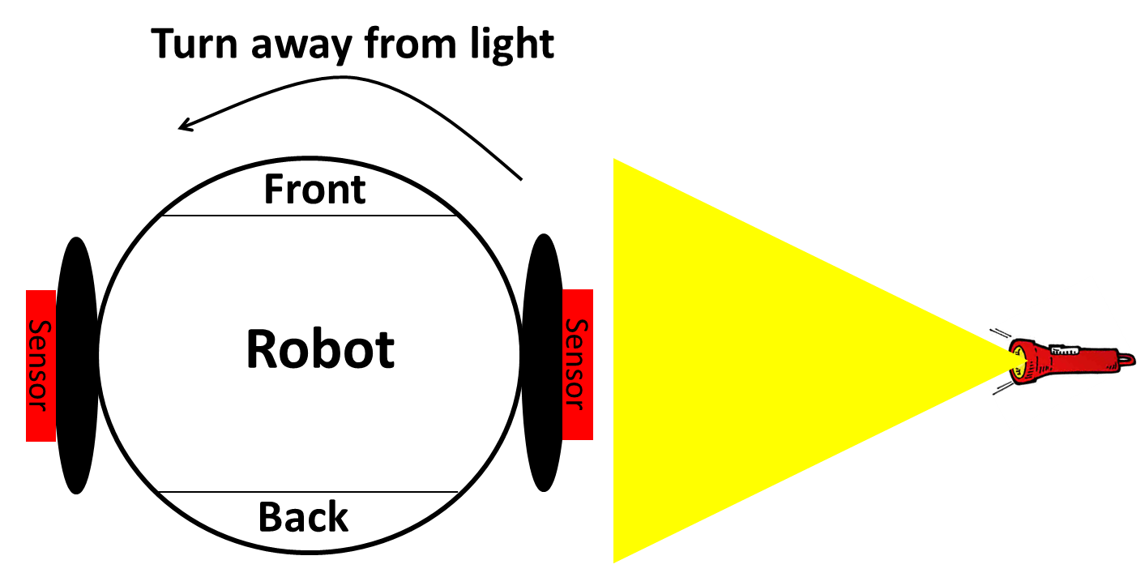

- Initialize TIMER 1 module A and B to meet the above requirements and so that both wheels initially move at 50% their maximum speed.

void init_TIMER1_A_B()
{

YOUR CODE HERE

}

- Initialize the ADC to meet the specification above. No interrupts are to be used

void init_ADC()
{

YOUR CODE HERE

}

- Complete the following API function to read in the light sensor values. Use polling (i.e. no Interrupt Service Routines).

void get_sensor_reading(int *left_sensor, int *right_sensor)
{

YOUR CODE HERE

}

- Complete the following API function to set the speed of each motor. The inputs should be specified on a 100-point scale (e.g. 50 means 50% speed). Assume the input parameters are no less than 1 and no greater than 99. Also rounding errors are acceptable (i.e. do NOT use floating-point calculations)

void set_motor_speed(int left_motor, int right_motor)
{

YOUR CODE HERE

}

- Complete main()

// Don’t go into the light program
main()
{
int left_sensor;
int right_sensor;
int left_motor;
int right_motor;

init_TIMER1_A_B();
init_ADC();

while(1)
{
get_sensor_reading(&left_sensor, &right_sensor);

// Computed motor speed commands
YOUR CODE HERE

set_motor_speed(left_motor, right_motor);
}
}

Question 2: Square Waves

a) For Timer 1 module B using PWM mode, generate a symmetric square wave (i.e. 50% duty cycle) with a 10 ms period. Assume the associated GPIO module has already been configured.

Note: You are not allowed to use any MACROs in your code, except for register names.
- Example: You will lose points for: GPIO_PORTA_DEN_R = GPIO_PORTA_DEN_R | PIN1
- Must use: GPIO_PORTA_DEN_R = GPIO_PORTA_DEN_R | 0b0000_0010; // or 0x02

void init_TIMER1()
{
YOUR CODE HERE
}

b) Now assume there is no PWM mode and that you have to use a Generic Waveform Generation approach (i.e. using an Interrupt Service Routine) to generate a symmetric square wave. Also assume the time to setup and execute the code in your ISR takes 20 µs (i.e. the CPU overhead involved with the ISR). What CPU utilize (i.e. percent of the CPU time) would be spent handing interrupts for:

i) Generating a square wave with a 10ms period

ii) Generating a square wave with a 100 µs period

iii) Generating a square wave with a 50 µs period.

c) What is the key trade-off between using a Generic Waveform Generation approach (i.e. using an Interrupt Service Routine) vs. a Timer in PWM Mode for generating a symmetric square wave?

Collaboration Documentation
List the people (First and Last name) you collaborated with: .

For each collaborator, describe the manner in which you collaborated:
1)
2)

