CPRE 288 Fall 2025 – Homework 5
Due Sunday September 28 (11:59pm on Canvas)
Notes:
- Homework must be typed and submitted as a PDF or Word Document (i.e. .doc or .docx) only.
- If collaborating with others, you must document who you collaborate with, and specify in what way you collaborated (see last page of homework assignment), review the homework policy section of the syllabus: http://class.ece.iastate.edu/cpre288/syllabus.asp for further details.
- Review University policy relating to the integrity of scholarship. See (“Academic Dishonesty”): http://catalog.iastate.edu/academic_conduct/#academicdishonestytext
- Late homework is accepted within two days from the due date. Late penalty is 10% per day. Exception: on Exam weeks no late homework accepted .
- Note 1: Code that will not compile is a typo. Answering a question as “will not compile” will be marked incorrect. Contact the Professor if you think you have found a typo.
- Note 2: You are not allowed to use any MACROs in your code, except for register names.
- Example: You will lose points for: GPIO_PORTA_DEN_R = GPIO_PORTA_DEN_R | PIN1
- Must use: GPIO_PORTA_DEN_R = GPIO_PORTA_DEN_R | 0b0000_0010; // or 0x02
Note: Unless otherwise specified, all problems assume the TM4C123 is being used

Question 1: GPIO Architecture (A CPRE 281 Digital Logic view)

All the devices (also called on-chip peripherals) on our Microcontroller must have their signals routed through the GPIO module if they want to interact with the outside world, via the package pins (i.e. chip’s external wires). The hardware structure of the GPIO module that allows a physical path from a device to a package pin (wire) can be illustrated using basic Digital Logic (i.e. CPRE 281) components.

Chapter 10 of the Microcontroller datasheet (General-Purpose Input/Outputs (GPIOs)) covers the details of how GPIO works on our platform. Additionally, Chapters 2, 4, and 7 of the textbook have sections that help explain important aspects of this part of the Datasheet. To help you work through this information, here is a guide to reduce your reading from ~56 pages of the datasheet to about 15 pages.

Read the following:
1) Datasheet Chapter 10: (~15 pages)
a) Skip: Sections 10.2.2 “Interrupt Control”, 10.2.4 “Commit Control”, 10.2.6 “Identification”.
b) In section 10.5 Register Descriptions, only Read the following important registers
i) Register 1: GPIO Data (GPIO_PORTX_DATA_R)
ii) Register 2: GPIO Direction (GPIO_PORTX_DIR_R)
iii) Register 10: GPIO Alternate Function Select (GPIO_PORTX_AFSEL_R)
iv) Register 18: GPIO Digital Enable (GPIO_PORTX_DEN_R)
v) Register 21: GPIO Analog Mode Select (GPIO_PORTX_AMSEL_R)
vi) Register 22: GPIO Port Control (GPIO_PORTA_PCTL_R)
c) Chapter 5.5, Registers Descriptions:
i) Register 60 General-Purpose Input/Output Run Mode Clock Gating Control (SYSCTL_RCGCGPIO_R)
d) Datasheet section 23.4 (Table 23-5): GPIO Pins and Alternate Functions. Same as Textbook Tables: Table 7.1, and Table 2.6

2) Textbook: Textbook chapters 2, 4, and 7 gives three takes on the content of Datasheet Chapter 10. Read though these as needed to help you understand the Datasheet.
a) Section 2.6.3: GPIO (~6.5pages)
i) Light read of 2.6.3.1: “The System Clock”
ii) Skip sections 2.6.3.3.4 - 5: “Commit and Interrupt Control Regs”
iii) In Section 2.6.3.3.6 “Pad Control Regs”, skip GPIODR2R – GPIOSLR
iv) Skip 2.6.3.3.7: Identification Reg.
b) Section 4.5.7.2 – 4.5.7.2.2.2, and 4.5.7.2.5.3 (Fig 4.33: DRAModel.c code) (~6.5 pages)
c) Section 7.1, 7.2, 7.3, Example application 7.4: Figure 7.7. (~13 pages)

To check how well you understand Chapter 10 of the datasheet, for Port A, using only registers and multiplexers (MUXs), provide a detailed diagram that shows:
- The connection between multiplexers associated with Port A’s Alternative Function Select (AFSEL) register, Port Control (PCTL) register, and Port A GPIO_DATA register.
- For each Device associate with Port A, show how they connect to the multiplexers of your diagram. For simplicity, assume all devices are used for output (i.e. no demultiplexers needed)
- For every input of each multiplexer in your diagram, label it with the value that MUX’s select line must have to allow that input to be selected.
- Show in detail how the AFSEL and PCTRL registers connect to the MUXs in your design.
- Note 1: Port A has 8 package pins (wires), thus your diagram needs to show: i) all 8 of these wires, and ii) for each of the 8 wires (package pins) how all the devices associated have data routed from the device to the package pin (wire).
- Fill in specific values of the AFSEL, and PCTRL registers that will configure your diagram so that.
  - Port A wire 0: Connects to CAN1RX
  - Port A wire 1: Connects to U0TX
  - Port A wires 2 – 4: Connect to GPIO_DATA
  - Port A wire 5: Connects to SSI0TX
  - Port A wire 6: Connects to I2C1SCL
  - Port A wire 7: Connects to M1PWM3
- Note 2: Your detailed diagram will likely fill a full sheet of paper.

Question 2: I/O Ports

- Complete the function init_ports based on the comments and figure below to configure Port B and Port C, while preserving the other Ports’ configuration.

void init_ports(void)
{
YOUR CODE HERE; // Start Port B and Port C clock
YOUR CODE HERE; // Enable Digital functionality of Port B and Port C
YOUR CODE HERE; //Set direction of Port B’s pins, based on the figure
YOUR CODE HERE; //Set direction of Port C’s pins, based on the figure

}

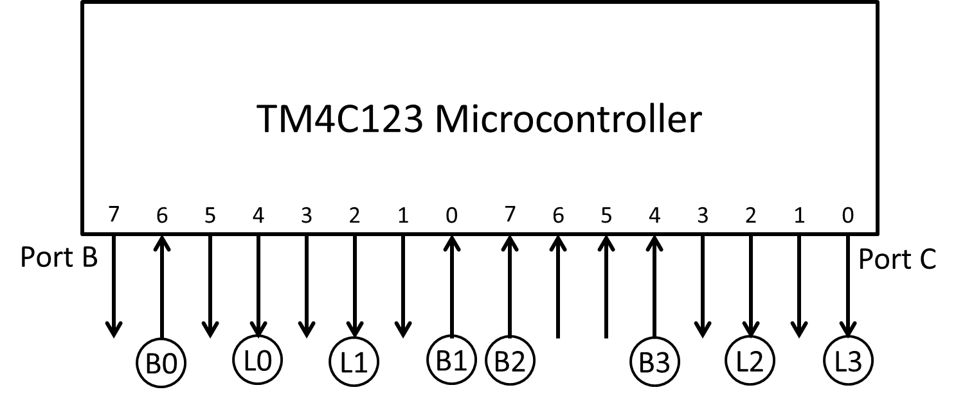
- Write C code that will read in button values, and send those values to their corresponding LEDs (i.e. B0 corresponds to L0), based on the figure in part a. Add any variables that you think you may need.

There are 4 buttons (B0, B1, B2, B3), whose values should be stored in elements 0 to 3 of buttons (i.e. button B0 should be stored in buttons[0]). There are four LEDs (L0, L1, L2, L3) that can have a value of 1 or 0 written to them. All wires that do not have an LED or button connected should have their value persevered (i.e. your code should not change their value).

void main(void)
{
unsigned char buttons[4];
init_ports(); // from part a

YOUR CODE HERE

}

Question 3: volatile keyword

When developing software for an embedded system, the keyword volatile is often used. Read through the articles below and answer the following:

Jones, Nigel. "Introduction to the Volatile Keyword" Embedded Systems Programming, July 2001: https://www.embedded.com/introduction-to-the-volatile-keyword/

Wikipedia Article: https://en.wikipedia.org/wiki/Volatile_(computer_programming)

a) Give a summary of the conditions under which the volatile keyword should be used within a C based embedded system, and why.

b) Assume you updated your solution for 2b, for the case where all the Buttons were connected to PortB, and all the LEDs were connected to PortC. Now look in tm4c123gh6pm.h (found on the course website resource page at “Tiva TM4C123GH6PM Device Register Names (Quick Look up)” ) for the definition of GPIO_PORTB_DATA_R. If this definition did not use the keyword volatile, then based on the articles you read about the keyword volatile, what type of issue do you think your solution may have?

Collaboration Documentation
List the people (First and Last name) you collaborated with: .
For each collaborator, describe the manner in which you collaborated:
1)
2)

