CprE 2880 Fall 2025 – Homework 7
Due Sunday October 19 (11:59 on Canvas)
Notes:
- Homework must be typed and submitted as a PDF or Word Document (i.e. .doc or .docx) only.
- If collaborating with others, you must document who you collaborate with, and specify in what way you collaborated (see last page of homework assignment), review the homework policy section of the syllabus: http://class.ece.iastate.edu/cpre288/syllabus.asp for further details.
- Review University policy relating to the integrity of scholarship. See (“Academic Dishonesty”): http://catalog.iastate.edu/academic_conduct/#academicdishonestytext
- Late homework is accepted within two days from the due date. Late penalty is 10% per day. Exception: on Exam weeks no late homework accepted
- Note: Code that will not compile is a typo. Answering a question as “will not compile” will be marked incorrect. Contact the Professor if you think you have found a typo.
- Note: You are not allowed to use any MACROs in your code, except for register names.
- Example: You will lose points for: GPIO_PORTA_DEN_R = GPIO_PORTA_DEN_R | PIN1
- Must use: GPIO_PORTA_DEN_R = GPIO_PORTA_DEN_R | 0b0000_0010; // or 0x02

Note: Unless otherwise specified, all problems assume the TM4C123 is being used

Question 1: Understanding Embedded System User needs.

As part of your training, to better contribute to your Project team’s choosing a problem to solve with an embedded system, this exercise with give you some experience with the first stage of this process: Identifying Users and their Needs. You will be collaborating with your Lab partner for this exercise.

A number of established tools exist to guide a team through this process. For this case, we will make use of two tools: 1) Empathy Maps, and 2) Point-of-View statements. Review the following two resources for a quick overview for how to use these two tools and the motivation for using them.

Empathy Map: https://www.interaction-design.org/literature/article/empathy-map-why-and-how-to-use-it

Point-of-View statements: https://www.interaction-design.org/literature/article/define-and-frame-your-design-challenge-by-creating-your-point-of-view-and-ask-how-might-we (steps 1-4)

Here is a very brief summary:
- Empathy Map: A structure to document and organize your “research” on Users (potential Users) in the topic area you are looking to solve a problem.
- Point-of-View statements: Leverages the User information you capture using a tool, such as an Empathy Map. This information is used to express a list of User needs in the form “User_A needs Need_B because Reason_C”. Simple example: “5 year old child needs a way to access a high bookshelf because they want to read”

After completing this process, you should:
1) Have a better sense for how to go about gathering information on Users
2) Get practice expressing their needs
3) Gain experience collaborating with your Lab partner by: a) agreeing upon a shared topic to pursue, and b) learning to share and give feedback on your User research, Empathy Map, and list of Point-of-View statements.
4) Be bettered prepared to go through a similar process while working with your Project team (4 person team) to develop your Team’s Project Proposal.

System View: The figure below shows the system view of this process. First, notes that you take while collecting User research from several sources will be organized and analyzed within an Empathy Map. The output from the Empathy Map will be a List of User needs in the form of Point-of-View statements.

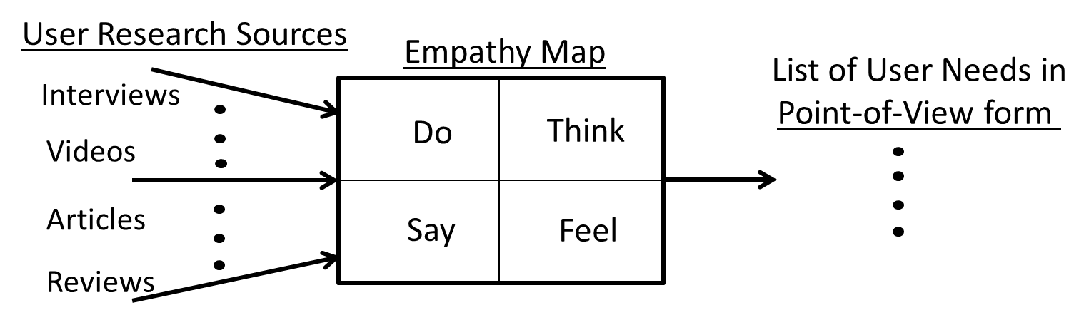
A) User Research: Gathering information on Users/Stakeholders (Potential User/Stakeholders). Stakeholders are a broader way to viewing Users, as they may be positively and/or negatively impacted by potential solutions to a problem.

i) Each Lab partner chooses a different type of User/Stakeholder for the topic area you are exploring.
ii) Each Lab partner choose at least 3 different types of sources for gathering User/Stakeholder information. Here are some examples:
- Online written product reviews (e.g. Amazon, Yelp, etc.)
- Online videos of Users using or talking about a product in your area (e.g. YouTube videos)
- Interview potential users
- Online case studies on the topic
- Online News articles
- ??
iii) Cite your sources
iv) Take notes on your observations. Type these up to be turned in as a Word Document or PDF document.

B) Empathy Map: Documenting and organizing User information

Using your notes, fill in an Empathy Map for the type of user you have chosen. This can be hand written or typed. You may even find sketching within the Empathy Map helpful. You will turn this in as a PDF. If you have handwritten or have sketches as part of your Empathy Map, then you may take a photo and upload as a PDF document.

C) List of Point-of-View statements: Extracting User needs from Empathy Map

Using your Empathy Map:
i) Make a list of as many needs as you can, placing needs related to the left half of the Empathy Map outside of the Empathy Map on the left, and needs related to the right half of the Empathy Map outside of it on the right.
ii) Formulate all or a subset of these needs in the form of Point-of-View statements. These statements should be typed and turned in as a Word or PDF document.
iii) Work with your lab partner(s) to develop a single Point-of-View statement that captures a major need that all your User types have in common. Make sure to indicate the name(s) of your Lab partners.

UART Readings:

Datasheet Chapter 14 (~10 pages of UART functionality)
a) Skip the following:
i) Skip: Sections 14.3.4 – 14.3.8
ii) Skip: Sections 14.3.10 – 14.3.11
b) Focus on the following registers: (mostly on registers 1-3, and 5-8)
i) Register 1: UART Data (UARTDR): UART#_DR_R
ii) Register 2: UART Receive Status/Error Clear (UARTRSR/UARTECR): UART#_RSR_R
iii) Register 3: UART Flag (UARTFR) : UART#_FR_R
iv) Register 5: UART Integer Baud-Rate Divisor (UARTIBRD) : UART#_IBRD_R
v) Register 6: UART Fractional Baud-Rate Divisor (UARTFBRD) : UART#_FBRD_R
vi) Register 7: UART Line Control (UARTLCRH): UART#_LCRH_R
vii) Register 8: UART Control (UARTCTL) : UART#_CTL_R
viii) Register 10: UART Interrupt Mask (UARTIM) : UART#_IM_R
ix) Register 11: UART Raw Interrupt Status (UARTRIS) : UART#_RIS_R
x) Register 12: UART Masked Interrupt Status (UARTMIS) : UART#_MIS_R
xi) Register 13: UART Interrupt Clear (UARTICR) : UART#_ICR_R
xii) Register 18: UART Clock Configuration (UARTCC) : UART#_CC_R
c) Textbook 8.5: for a good supplement to the Datasheet. Use as needed (~20pages)
i) Note: There is a nice and useful application example (Figure 8.73)

Question 2: UART Basics
a) Sketch the logic waveform appearing at the output of the UART when it transmits a character ‘T’ at a baud rate of 9,600. The sketch should show the bit durations in microseconds, in addition to the waveform. The frame format is of 1 start bit, 8 data bits, an odd parity bit, and 2 stop bits.

b) What is the data rate of the UART configuration given in part a?

Question 3 Software vs. Hardware implemented UART
a.) Software: Assume there is no UART hardware device. Complete functions init_portB(), and serial_send(char my_txt) to implement the UART protocol in software.
Given: Assume you have available a function called wait_us(float WaitTime) that waits for WaitTime microseconds before continuing.
// Configure pin 3 of Port B as an GPIO output
void init_portB()
{

}

// Send my_txt out of Port B pin 3 encoded in the UART frame and
// speed specification given in Question 2. Since there is no
// UART device, your code must use the GPIO Data Register of
// Port B pin 3 to transmit the 8-bits of my_txt.
void serial_send(char my_txt)
{

}
b.) Hardware: Complete serial_init and serial_send making use of the UART hardware device.

i) Complete the function serial_init to configure UART0 to:
- Match the specifications given in Question 2
- Enable transmitting, Disable receiving
- No interrupts used (so ignore registers related to interrupts)
- Set up the GPIO registers to allow UART0 to transmit. Preserve all other GPIO settings.

// Initialize UART0 and associated GPIO Port/pins
void serial_init()
{

}

ii) Complete function serial_send to transmit my_txt using hardware device UART0

// Send my_text using the hardware device UART0
serial_send(char my_txt)
{

}

Question 4: UART Receiving a byte Interrupt Hardware
The figure below shows a simplified hardware architecture for the UART interrupts sub-system. It is composed of software programmable registers (IM, RIS, MIS, ICR), along with logic gates. In this question you will design a circuit to complete the UART interrupt sub-system hardware. You will then complete software to make use of this simplified UART interrupt sub-system.
a) Design a CPRE 281 style digital circuit to place in the “Falling Edge Detector” box of the UART Interrupt sub-system. This will be used to detect when a new UART frame begins to arrive. Recall the start symbol of a UART frame is indicated by the UART RX wire transitioning from high to low (i.e. a falling or negative edge occurs). To keep your circuit simple, use to following assumptions:

- Your circuit should pulse the “detect” signal for 1 clock cycle whenever a falling edge on the RX wire occurs. In other words, “detect” should become ‘1’ for exactly one clock cycle.
- You are limited to using the following types of components: AND, OR, NOT, XOR, D Flip-Flops
- Your circuit should use at least 1 D Flip-Flop, but not more than 2. And you can use at most 4 total components.
- Assume anytime the RX wire goes low it will stay low for at least one clock cycle.
- Falling Edge Detector
  - Inputs: UART RX wire, and a clock
  - Output: detect signal

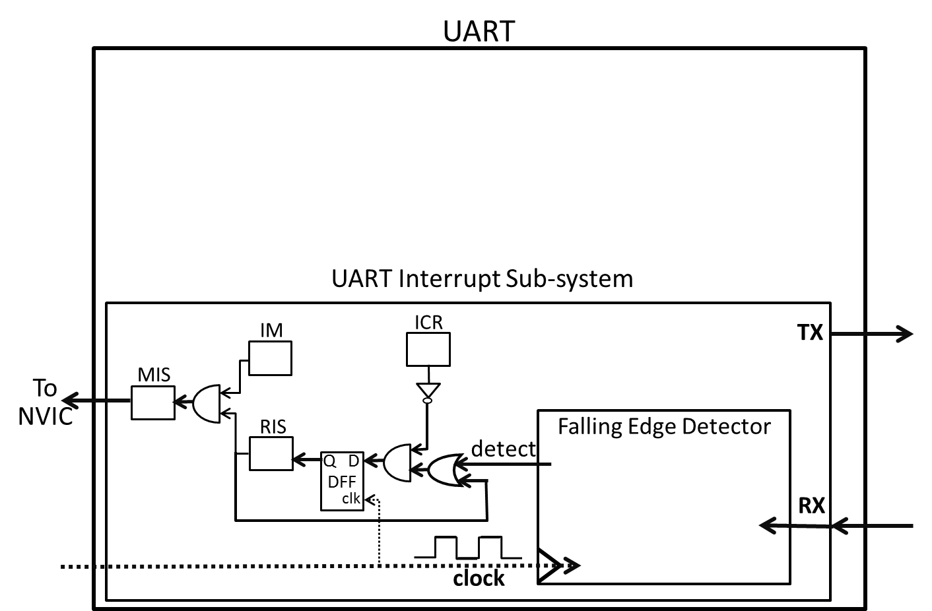
b) Provide code to complete init_UART() and My_UART_Handler().

volatile int flag = 0; // Helper variable
int main()
{
init_UART(); // Initializes the GPIO and UART

while (1)
{
//Print each time a new UART Frame begins
if(flag == 1)
{
printf(“Starting to Receive a new UART Frame \n”);
flag = 0; reset flag.
}
}

return 0;
}

void init_UART()
{
// Assume GPIO has already been initialized for you.
// Assume all aspects of the UART except interrupts have been
// configured for you

// Assume the register size of IM, RIS, MIS, and ICR are 1 bit
// Assume these register names have been memory mapped so you
// can directly assign values to these names.

// Place YOUR CODE HERE to enable the Start of Frame Interrupt

// Assume the NVIC has been configured for you

//Binds UART interrupt requests to My_UART_Handler
IntRegister(INT_UART, My_UART_Handler);
}

// UART ISR (Give code for the ISR)
void My_UART_Handler()
{
// Check if an Interrupt has really occurred

// Set flag so main() knows interrupt occurred

// clear the Interrupt.
}

Question 5: Interrupt based UART data processing
In this question data received by UART 0 will be processed by an Interrupt Service Routine.
a) Write the serial_init() function to initialize UART0 as follows:
- Receive Only
- 9,600 baud rate
- 8 data bits
- Even parity
- 2 stop bit
- Disable FIFOs
- Enable UART Receive interrupts only
You may initialize unrelated control bits as you wish.
// Initialize UART0
void serial_init()
{

//Binds UART0 interrupt requests to My_UART0_RX_Handler
IntRegister(INT_UART1, My_UART0_Handler);
IntMasterEnable();//Globally allows CPU to service interrupts

}

b) Write code for My_UART0_Handler to implement the Interrupt Service Routine (ISR) that processes the occurrence of a UART0 received data interrupt. In addition, within this ISR turn on an LED connected to GPIO Port B pin 3 when an ‘L’ (for Light) is received by UART0 by writing a 1 to the LED, and turn off this LED when an ‘O’ (for Off) is received by writing a 0 to the LED.

// UART0 ISR
void My_UART0_Handler()
{

}

c) Complete main() to print “LED turned ON” and “LED turned OFF” once each time the LED is turned on or off respectively.
void My_UART0_Handler();
void serial_init(void);

volatile int flag = 0; // Helper variable

int main()
{
init_portB(); // Assume implemented correctly in Question 2
serial_init();

while (1)
{

//Print each time the LED is turned ON or OFF
//Hint: make use the helper variable flag declared above.
// YOUR CODE HERE

}

return 0;

}

ADC Readings:

ADC Datasheet Readings: Analog to Digital Converter (ADC): Chapter 13(~8 pages on functionality)
a) Skip the following
i) Skip: Section 13.3.2.2: DMA
ii) Skip: Section 13.3.2.3: Prioritization
iii) Skip: Sections 13.3.2.5 – 13.3.3: Sample Phase Control – Hardware Sample Averaging
iv) Skip: Sections 13.3.5 – 13.3.7: Differential Sampling – Digital Compart Unit
b) Important registers:
i) Register 1: ADC Active Sample Sequencer (ADCACTSS): ADC#_ACTSS_R
ii) Register 2: ADC Raw Interrupt Status (ADCRIS): ADC#_RIS_R
iii) Register 3: ADC Interrupt Mask (ADCIM) : ADC#_IM_R
iv) Register 4: ADC Interrupt Status and Clear (ADCISC) : ADC#_ISC_R
v) Register 6: ADC Event Multiplexer Select (ADCEMUX) : ADC#_EMUX_R
- only settings 0x0 and 0xF
vi) Register 11: ADC Processor Sample Sequence Initiate (ADCPSSI) : ADC#_SSPRI_R
vii) Register 15,27,28,35:ADC Sample Sequence Input Multiplexer Select (0-3) (ADCSSMUX0-3):
ADCn_SSMUX#_R
viii) Register 16,29,30,36: ADC Sample Sequence Control(0-3) (ADCSSCTL0-3):
ADCn_SSCTL#_R
ix) Register 17-20:ADC Sample Sequence Result FIFO(0-3) (ADCSSFIFO0-3):
ADC#_SSFIFO#_R
x) Register 58: ADC Clock Configuration (ADCCC) : ADC#_CC_R Only setting 0x0.
xi) Sec 5.5, page 352: Register 68: Analog-to-Digital Converter Run Mode Clock Gating Control
(RCGCADC) : SYSCTL_RCGCADC_R
c) Textbook 7.5: for a good supplement to the Datasheet. Read as needed (~30pages)
i) Note: Figure 7.8 is VERY useful and IMPORTANT
ii) Note: First 10 pages give a quick summary of operation
iii) Note: In Figure 7.8. There is no register ADCSSEMUX for the Sample Sequencer.
iv) Note: There is also a nice application example (Figure 7.29)

Question 6: ADC Design Principle

Suppose that an TM4C123 is used with a pressure sensor to monitor the pressure exerted on a valve. The pressure sensor measures pressure from 50.0psi (pounds per square inch) to 550.0psi and converts it proportionally (i.e. linearly) to an electrical signal in the voltage range from 0V to 2.5V. Assume the reference voltage (i.e. max voltage) for the TM4C123 ADC is 5V.

- If the gas pressure is 350.0 psi:

i) what is the voltage level at the sensor’s output?

ii) What is the digital reading from the TM4C123 ADC?

b. If the digital reading was 200, what is the range of possible analog values just read?

Collaboration Documentation
List the people (First and Last name) you collaborated with: .
For each collaborator, describe the manner in which you collaborated:
1)
2)

