CprE 288 Fall 2025 – Homework 8
Due Sunday October 26 (11:59 on Canvas)
Notes:
- Homework must be typed and submitted as a PDF or Word Document (i.e. .doc or .docx) only.
- If collaborating with others, you must document who you collaborate with, and specify in what way you collaborated (see last page of homework assignment), review the homework policy section of the syllabus: http://class.ece.iastate.edu/cpre288/syllabus.asp for further details.
- Review University policy relating to the integrity of scholarship. See (“Academic Dishonesty”): http://catalog.iastate.edu/academic_conduct/#academicdishonestytext
- Late homework is accepted within two days from the due date. Late penalty is 10% per day. Exception: on Exam weeks no late homework accepted
- Note: Code that will not compile is a typo. Answering a question as “will not compile” will be marked incorrect. Contact the Professor if you think you have found a typo.
- Note: You are not allowed to use any MACROs in your code, except for register names.
- Example: You will lose points for: GPIO_PORTA_DEN_R = GPIO_PORTA_DEN_R | PIN1
- Must use: GPIO_PORTA_DEN_R = GPIO_PORTA_DEN_R | 0b0000_0010; // or 0x02
Note: Unless otherwise specified, all problems assume the TM4C123 is being used

ADC Readings:
ADC Datasheet Readings: Analog to Digital Converter (ADC): Chapter 13(~8 pages on functionality)
a) Skip the following
i) Skip: Section 13.3.2.2: DMA
ii) Skip: Section 13.3.2.3: Prioritization
iii) Skip: Sections 13.3.2.5 – 13.3.3: Sample Phase Control – Hardware Sample Averaging
iv) Skip: Sections 13.3.5 – 13.3.7: Differential Sampling – Digital Compart Unit
b) Important registers:
i) Register 1: ADC Active Sample Sequencer (ADCACTSS): ADC#_ACTSS_R
ii) Register 2: ADC Raw Interrupt Status (ADCRIS): ADC#_RIS_R
iii) Register 3: ADC Interrupt Mask (ADCIM) : ADC#_IM_R
iv) Register 4: ADC Interrupt Status and Clear (ADCISC) : ADC#_ISC_R
v) Register 6: ADC Event Multiplexer Select (ADCEMUX) : ADC#_EMUX_R
- only settings 0x0 and 0xF
vi) Register 11: ADC Processor Sample Sequence Initiate (ADCPSSI) : ADC#_SSPRI_R
vii) Register 15,27,28,35:ADC Sample Sequence Input Multiplexer Select (0-3) (ADCSSMUX0-3):
ADCn_SSMUX#_R
viii) Register 16,29,30,36: ADC Sample Sequence Control(0-3) (ADCSSCTL0-3):
ADCn_SSCTL#_R
ix) Register 17-20:ADC Sample Sequence Result FIFO(0-3) (ADCSSFIFO0-3):
ADC#_SSFIFO#_R
x) Register 58: ADC Clock Configuration (ADCCC) : ADC#_CC_R Only setting 0x0.
xi) Sec 5.5, page 352: Register 68: Analog-to-Digital Converter Run Mode Clock Gating Control
(RCGCADC) : SYSCTL_RCGCADC_R
c) Textbook 7.5: for a good supplement to the Datasheet. Read as needed (~30pages)
i) Note: Figure 7.8 is VERY useful and IMPORTANT
ii) Note: First 10 pages give a quick summary of operation
iii) Note: In Figure 7.8. There is no register ADCSSEMUX for the Sample Sequencer.
iv) Note: There is also a nice application example (Figure 7.29)

Question 1: ADC subsystem

The figure below shows the voltage being applied to a number of the ADC analog inputs (AIN). Answer the following questions based on this figure and based on the following assumptions:
- The ADC is an 10-bit ADC
- The ADC input range is from 0V (Vmin) to 256V (Vmax)
- The ADC has M = 2^{n} steps, where n is the number of ADC output bits.
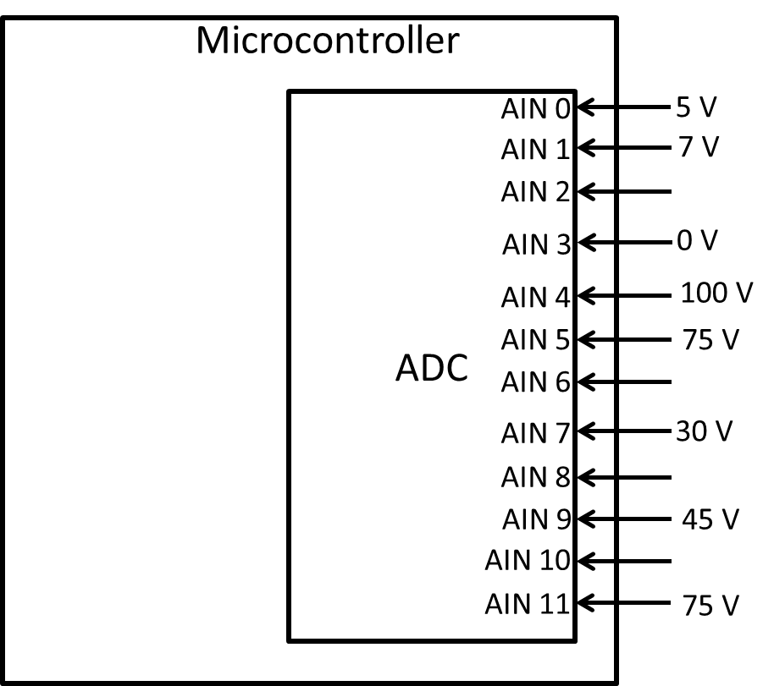
  - What is the resolution of the ADC in V/bit?

  - Complete the following code. Assume:
- GPIO registers have already been configured correctly
- ADC initialization registers have already been configured correctly
- That ADC conversion will be initiated (i.e. triggered/started) by Software
- Polling will be used to determine when the ADC has completed all its conversions

Each value you specify MUST be in binary, hex, or decimal.
main()
{
int i;
unsigned short results[100]; // Array to place ADC results
// Sample Sequencer Input Multiplexer Select (SSMUX0)
ADC0_SSMUX0_R = 0x710B_9453;

// Sample Sequencer Control (SSCTL0)
ADC0_SSCTL0_R = 0x4404_0600;

// Start ADC conversion
ADC0_PSSI_R = ; // SS0

// Wait for the ADC to complete all of its conversions

while( (~ADC0_RIS_R & ) ) // SS0
{
}
ADC0_ISC_R = ; // SS0

// Place the converted values into the results array
for(i=0; i < ; i++)
{

// Place code in for body

}

// Print the results
for(i=0; i < ; i++)
{
printf(“%d ”, results[i]);
}
}
  - Using the assumptions of the given figure and the code of part b, give the values printed by part b.

  - Assume the voltage of ADC input 7 (i.e. AIN7) of the Figure is provided by a sensor that measures temperature. Furthermore, assume the voltage produced by this sensor is linear to the temperature measured, its specified temperature input measurement range is 0 degrees to 100 degrees, and its corresponding output voltage range is 0V to 200V. Fort the AIN7 voltage given in the figure, what temperature is this sensor detecting?

Timer Readings:
Datasheet Reading Guide: General-Purpose Timers: Chapter 11 (~15 pages on functionality)
a) Skip the following
i) Skip: Section 11.3.2.2: Real-Time Clock Timer Mode
ii) Skip: Section 11.3.2.3: Input Edge-Count Mode
iii) Skip: Sections 11.3.3 – 11.3.5: Wait-for-Trigger Mode, Synchronizing GP Timer Blocks, DMA
iv) Skip: Section 11.3.7: Accessing Concatenated 32/64-Bit Wide GPTM Register Values
b) Important registers:
i) Register 1: GPTM Configuration (GPTMCFG): TIMER#_CFG_R
ii) Register 2,3: GPTM Timer A(B) Mode(GPTMTA(B)MR): TIMER#_TA(B)MR_R
iii) Register 4: GPTM Control (GPTMCTL) : TIMER#_CTL_R
iv) Register 6: GPTM Interrupt Mask (GPTMIMR) : TIMER#_IMR_R
v) Register 7: GPTM Raw Interrupt Status (GPTMRIS): TIMER#_RIS_R
vi) Register 8: GPTM Masked Interrupt Status (GPTMMIS) : TIMER#_MIS_R
vii) Register 9: GPTM Interrupt Clear (GPTMICR) : TIMER#_ICR_R
viii) Register 10,11: GPTM Timer A(B) Interval Load (GPTMTA(B)ILR) : TIMER#_TA(B)ILR_R
ix) Register 12,13:GPTM Timer A(B) Match(GPTMTA(B)MATCHR): TIMER#_TA(B)MATCHR_R
x) Register 14,15: GPTM Timer A(B) Prescale (GPTMTA(B)PR) : TIMER#_TA(B)PR_R
xi) Register 16,17: GPTM TimerA Prescale Match (GPTMTAPMR) : TIMER#_TA(B)PMR_R
xii) Register 18,19: GPTM Timer A (GPTMTAR) : TIMER#_TA(B)R_R
xiii) Register 20, 21: GPTM Timer A(B) Value (GPTMTAV) : TIMER0_TA(B)V_R
xiv) Sec 5.5, page 338: Register 59: GP Timer Run Mode Clk Gating Control: SYSCTL_RCGCTIMER_R
c) Textbook 9.1 – 9.2: a good supplement to the Datasheet, as needed (~30pages)
i) Note: Figure 9.1 is useful
ii) Note: Figure 9.10 is a useful Periodic Timer code example
iii) Note: Figure 9.14 is a useful Input-Edge Time Mode (Input capture) code example.
iv) Note: There 9.17 is a useful PMW Mode code example.

Question 2: General Timer question

Briefly describe each Timer mode given in Datasheet Table 11.3 (or Textbook Table 9.1).

Collaboration Documentation
List the people (First and Last name) you collaborated with: .
For each collaborator, describe the manner in which you collaborated:
1)
2)

