CprE 288 Fall 2024 – Homework 9
Due Sunday Nov 3. (on Canvas 11:59pm)
Notes:
- Homework must be typed and submitted as a PDF or Word Document (i.e. .doc or .docx) only.
- If collaborating with others, you must document who you collaborate with, and specify in what way you collaborated (see last page of homework assignment), review the homework policy section of the syllabus: http://class.ece.iastate.edu/cpre288/syllabus.asp for further details.
- Review University policy relating to the integrity of scholarship. See (“Academic Dishonesty”): http://catalog.iastate.edu/academic_conduct/#academicdishonestytext
- Late homework is accepted within two days from the due date. Late penalty is 10% per day. Exception: on Exam weeks no late homework accepted
- Note: Code that will not compile is a typo. Answering a question as “will not compile” will be marked incorrect. Contact the Professor if you think you have found a typo.
- Note: You are not allowed to use any MACROs in your code, except for register names.
- Example: You will lose points for: GPIO_PORTA_DEN_R = GPIO_PORTA_DEN_R | PIN1
- Must use: GPIO_PORTA_DEN_R = GPIO_PORTA_DEN_R | 0b0000_0010; // or 0x02

Note: Unless otherwise specified, all problems assume the TM4C123 is being used

Timer Readings:
Datasheet Reading Guide: General-Purpose Timers: Chapter 11 (~15 pages on functionality)
a) Skip the following
i) Skip: Section 11.3.2.2: Real-Time Clock Timer Mode
ii) Skip: Section 11.3.2.3: Input Edge-Count Mode
iii) Skip: Sections 11.3.3 – 11.3.5: Wait-for-Trigger Mode, Synchronizing GP Timer Blocks, DMA
iv) Skip: Section 11.3.7: Accessing Concatenated 32/64-Bit Wide GPTM Register Values
b) Important registers:
i) Register 1: GPTM Configuration (GPTMCFG): TIMER#_CFG_R
ii) Register 2,3: GPTM Timer A(B) Mode(GPTMTA(B)MR): TIMER#_TA(B)MR_R
iii) Register 4: GPTM Control (GPTMCTL) : TIMER#_CTL_R
iv) Register 6: GPTM Interrupt Mask (GPTMIMR) : TIMER#_IMR_R
v) Register 7: GPTM Raw Interrupt Status (GPTMRIS): TIMER#_RIS_R
vi) Register 8: GPTM Masked Interrupt Status (GPTMMIS) : TIMER#_MIS_R
vii) Register 9: GPTM Interrupt Clear (GPTMICR) : TIMER#_ICR_R
viii) Register 10,11: GPTM Timer A(B) Interval Load (GPTMTA(B)ILR) : TIMER#_TA(B)ILR_R
ix) Register 12,13:GPTM Timer A(B) Match(GPTMTA(B)MATCHR): TIMER#_TA(B)MATCHR_R
x) Register 14,15: GPTM Timer A(B) Prescale (GPTMTA(B)PR) : TIMER#_TA(B)PR_R
xi) Register 16,17: GPTM TimerA Prescale Match (GPTMTAPMR) : TIMER#_TA(B)PMR_R
xii) Register 18,19: GPTM Timer A (GPTMTAR) : TIMER#_TA(B)R_R
xiii) Register 20, 21: GPTM Timer A(B) Value (GPTMTAV) : TIMER0_TA(B)V_R
xiv) Sec 5.5, page 338: Register 59: GP Timer Run Mode Clk Gating Control: SYSCTL_RCGCTIMER_R
c) Textbook 9.1 – 9.2: a good supplement to the Datasheet, as needed (~30pages)
i) Note: Figure 9.1 is useful
ii) Note: Figure 9.10 is a useful Periodic Timer code example
iii) Note: Figure 9.14 is a useful Input-Edge Time Mode (Input capture) code example.
iv) Note: There 9.17 is a useful PMW Mode code example.

Question 1: Software implemented Input Capture

a) Assume the TM4C123 does not have Input Capture hardware or Interrupts. Write a C program to save TIMER1A’s value (i.e. TIMER1_TAR_R) when a positive edge event occurs on PortD, pin4. Note/Hint: you may want to complete part c first.

Assume:
- GPIO has already been configured properly for you
- The Timer has already been configured into Periodic Mode for you

int main(void)
{
unsigned int rising_edge_time;

// YOUR CODE HERE

}

b) Describe two disadvantages of your software-implemented input capture program has compared to using Input Capture hardware with Interrupts.

c) Complete the bubble diagram below to implement a Mealy State Machine that implements a positive edge detector (i.e. the state machine outputs 1 each time a positive edge occurs on the input). Assume at Start the state machine input is initially 0.

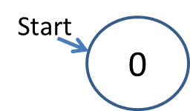

Question 2: Edge Detection
The following simple block diagram illustrates how one may implement an Input Capture circuit.
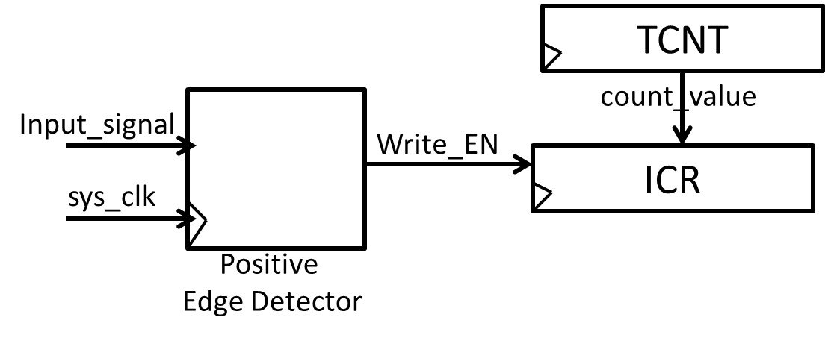
An example timing diagram for capturing the rising edge of Input_signal is given below. In summary, on the occurrence of a positive edge on Input_signal: 1) Write_EN pulses ‘1’ for one sys_clk cycle, and 2) the value in the Timer/Counter Register (count_value) is loaded into the Input Capture Register (ICR).
Assume: Any time Input_signal transitions is will hold its value for at least 1 sys_clk cycle.

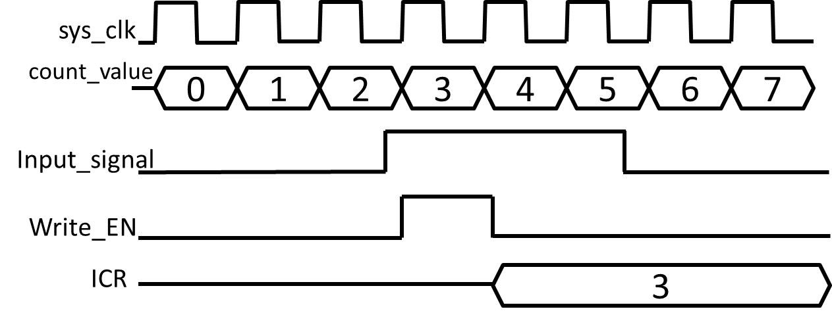

a) Draw out a digital circuit to implement an Edge Detector that creates a 1-sys_clk-wide pulse on Write_EN to load count_value register into the ICR register when a rising edge occurs on Input_signal. The only components you can use are D-Flip Flops, and AND, OR, NOT gates. Hint: Think about what information you need conceptually to identify that a rising edge has occurred.

b) Repeat a) for an edge detector that creates a Write_EN pulse for detecting the falling edge of Input_signal.

c) Let us assume we can configure the hardware for detecting either the positive edge or negative edge of an input by configuring the “Edge Select” bit of a configuration register (call it the Edge Select bit: ES). Draw the digital circuit to allow the Edge Detector to detect a positive edge when ES=1, and a negative edge when ES=0. You may now use multiplexers in addition to D-Flip Flops, and AND, OR, NOT gates.

Question 3: Shutdown system
A pressure sensor is embedded in the ramp below. When pressure is applied to the sensor, a logic 1 is driven on the Timer 1 Input Capture input wire of the TM4C123, else a logic 0 is driven. You are to write a C-program that will apply the car’s breaks to stop it if its velocity is not large enough to jump the gap shown below. This program is required to use the Timer 1 Input Capture interrupt. (Reminder: the System clk of our Microcontroller is 16 MHz)
Note: You are not allowed to use any MACROs in your code, except for register names.
- Will lose points for: GPIO_PORTA_DEN_R = GPIO_PORTA_DEN_R | PIN1
- Must use: GPIO_PORTA_DEN_R = GPIO_PORTA_DEN_R | 0b0000_0010; // or 0x02

Assumptions:
1) The car is moving at a constant velocity while on the ramp
2) The car is treated as a “point mass” for computing the physics of the problem

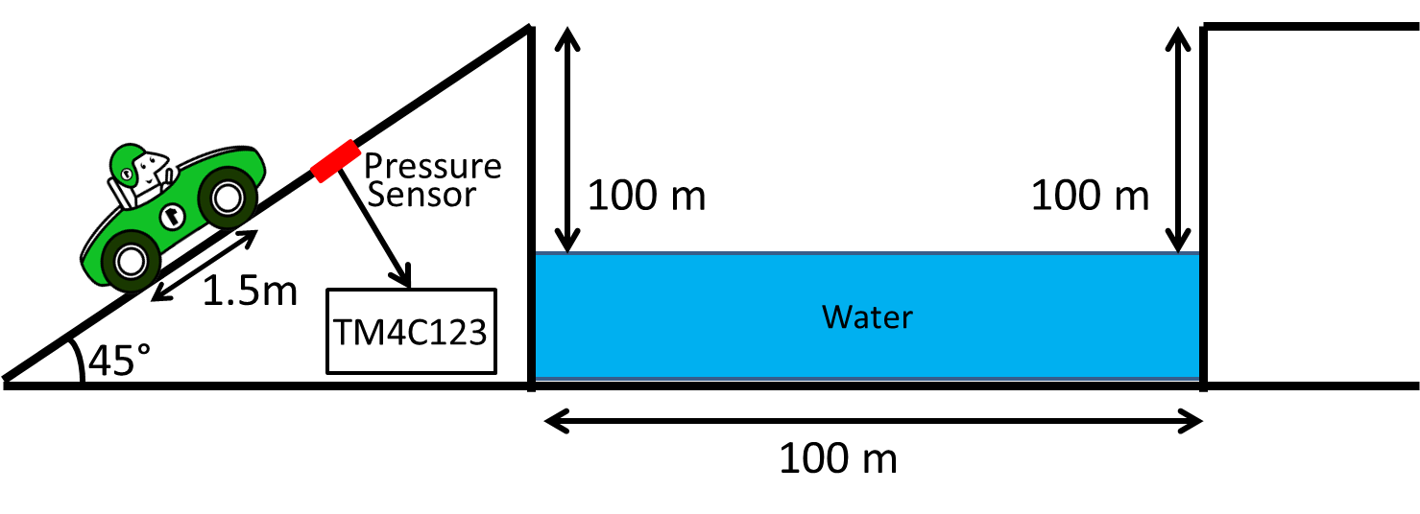

a) Complete Config_Timer1 to program the Timer 1 configuration registers as follows:
- Input Capture interrupt enabled
- 24-bit timer
- Detect positive edge events

Config_Timer1()
{

// YOUR CODE HERE
}

b) Complete the ISR (i.e. handler) called Timer_1_Handler to store first_wheel_hit and second_wheel_hit

c) Complete Stop_car(). It should return 1 if the car is not moving fast enough to jump the gap

// Global variables (you may use additional variables)
volatile unsigned int first_wheel_hit; // When 1st wheel hits sensor
volatile unsigned int second_wheel_hit; // When 2nd wheel hits sensor
volatile int done_flag=0; // 1 after both first and second_wheel_hit
// have been stored

// Store first_wheel_hit and second_wheel_hit
void Timer_1_Handler(void)
{

//YOUR CODE HERE

}

// Return 1 if the car is not fast enough to jump the gap
int Stop_car(void)
{

//YOUR CODE HERE

}

// Program to stop Car if it is not fast enough to jump
// the gap.
main()
{

int stop = 0;

Config_Timer1();

while(1)
{
// Wait for events to be captured
while(!done_flag)
{
}

done_flag = 0; // Clear flag

// Check if car needs to stop
stop = Stop_car();

if(stop)
{
lprintf(“Stopping Car!”;
}
else
{
lprintf(“Car going to Jump!!”);
}

} // end while
}

Question 4: Timer Accuracy
A laser that works similar to your PING sensor is used to measure the distance to the Moon from Earth. The laser is fired at a mirror placed on the Moon, and a sensor attached to the laser detects when the reflection arrives back to the laser. As shown below. This is similar to an actual method used for measuring the Earth-Moon distance, see: http://en.wikipedia.org/wiki/Lunar_Laser_Ranging_experiment
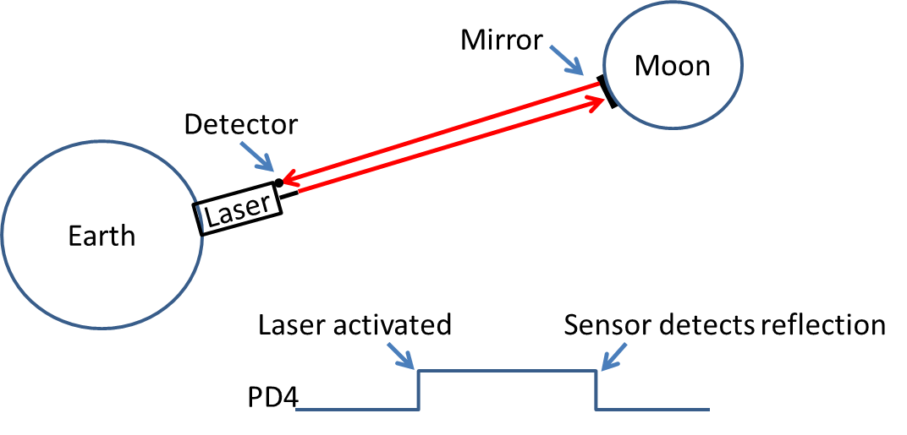
When the laser is activated, TIMER1’s Input Capture pin is set to a 1. When the sensor detects the reflection, this pin is set to 0. A program has been written that uses Input Capture to compute the distance between the Earth and the Moon.
Given that Input Capture measures time in Timer ticks (i.e. clock cycles), how different can the programs calculation of the Earth-Moon distance be from the actual distance?
a) Explain what causes the error in the measured distance.

b) Compute the maximum error in distance for each the following speeds of the system clock used by TIMER1: 16MHz, 1MHz, 1KHz.

Collaboration Documentation
List the people (First and Last name) you collaborated with: .

For each collaborator, describe the manner in which you collaborated:
1)
2)

