EE 330 Quiz #03

Name: Score

Grader:

Briefly answer the following questions:

1. Find the logic expression for: 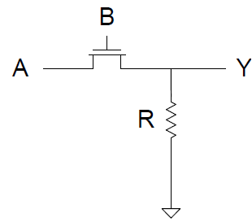Y=AB
2. Find the logic expression for: 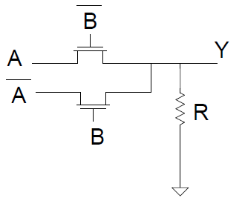Y=A_bar B + A B_bar, = A (or)B
3. Find the logic expression for: 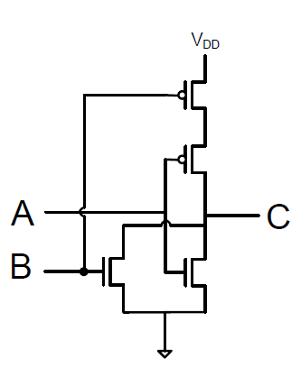C=(A+B)_bar
4. In the switch level model for NMOS, when G =1, V_ds=0, DS short, D=0
5. In the switch level model for NMOS, when G =0, I_ds=0, DS open
6. In the switch level model for PMOS, when G =1, I_ds=0, DS open
7. In the switch level model for PMOS, when G =0, V_ds=0, DS short, D=0
8. In the improved switch level model for NMOS, the gate is connected to cap, Cgs
9. When transistor is on, the drain to source is modeled as R
10. When transistor is off, the drain to source is modeled as open