**Setting Up Tektronix Instruments for Use with Signal Express**

In this guide we will quickly go over how to set up and use Tektronix Function Generators and Oscilloscopes for automated testing with NI Signal Express (SE).

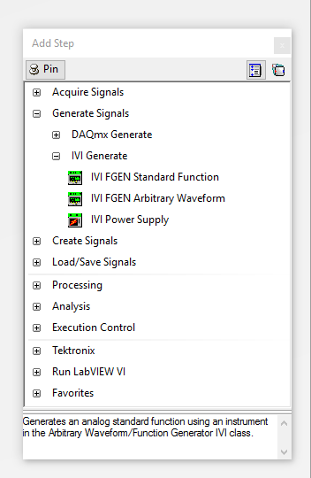For those who have taken 201 and 230 at ISU prior to Fall 2017, you’re probably familiar with using Tektronix own designed blocks in SE. However, this year Tektronix quit supporting their Signal Express edition, so know we will be using NI’s generic IVI blocks instead to set up and configure our tests.

Figure

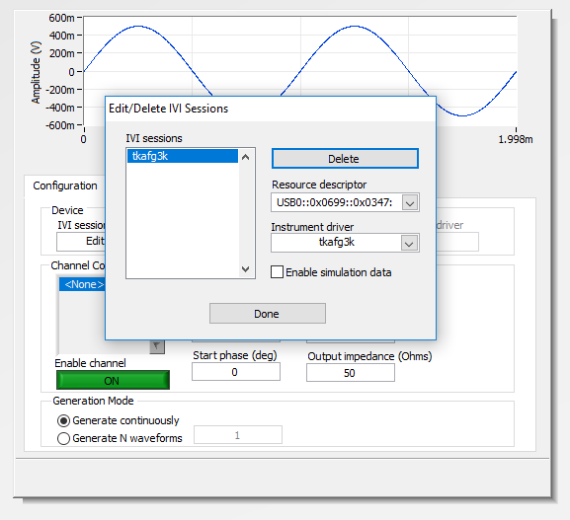After you’ve started a new SE project, go ahead and add the IVI FGEN Standard Function step as shown in *Figure 1.* Now edit the session by clicking on the drop down under IVI session name. Select the correct Resource Descriptor for the Function Generator. This information can be found using NI Max and clicking on the *Devices and Interfaces* (note: many times Tektronix’s Function Generators appear as Unknown Devices in NI). Then select the correct driver in the same screen *tkafg3k*. Also, make sure the *Enable Simulation Data* is NOT checked. You should see something similar to *Figure 2*.

Figure

Now do the same for the oscilloscope. Only difference here is you’re acquiring the signal and will need to use the *tkdpo4k* instrument driver for the scope. At this point your instruments should be ready to use and any configuration errors will come from incorrect settings with in the IVI block. See configuration error details to assist in finding the cause. Good Luck with your lab.