***EDU1000 Datasheet***

CMOS MOSFET ARRAY

**(Acknowledgement:** Special thanks to Texas Instruments for their generous support for providing these MOS array chips)

RECOMMENDED OPERATING CONDITIONS:

Nominal operating conditions should be selected so that the operation is always within the following ranges:

|  |  |  |
| --- | --- | --- |
| CHARACTERISTIC / PARAMETER | TYPICAL | UNITS |
|
| Vin | 0 to 2.5 | $$V$$ |
| Vdd,max | 3 | $$V$$ |
| $$μCox$$ | $$150$$ | $$μA / V^{2}$$ |
| Vtn | $$0.5$$ | $$V$$ |
| Λ | $$.015$$ | $$V^{-1}$$ |
| Γ | $$0.6$$ | $$V^{0.5}$$ |

PIN CONFIGURATION: PIN FUNCTIONS: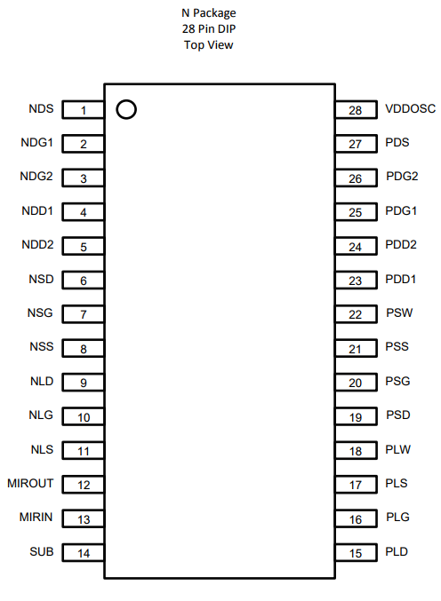 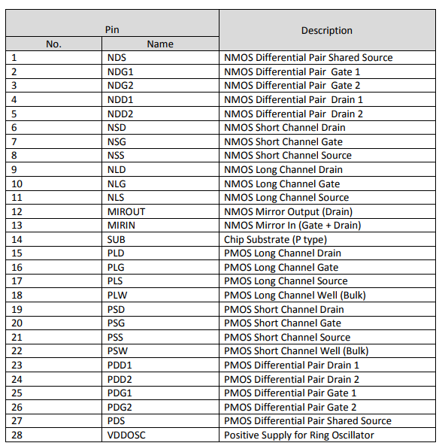

MOS CONFIGURATIONS: W/L values indicated

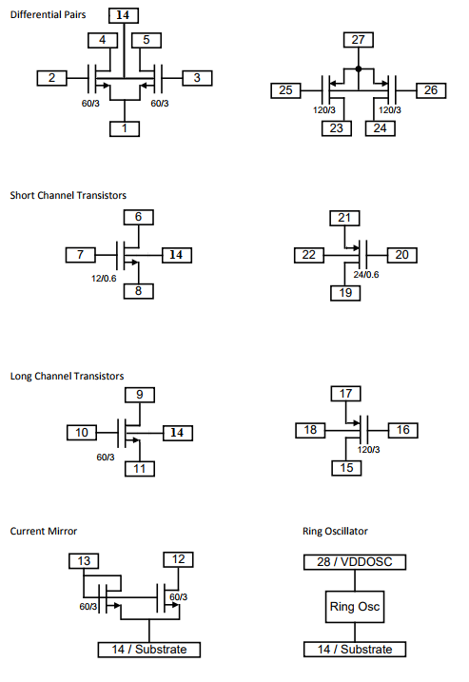

I-V CHARACTERISTICS:

NMOS Long Channel:

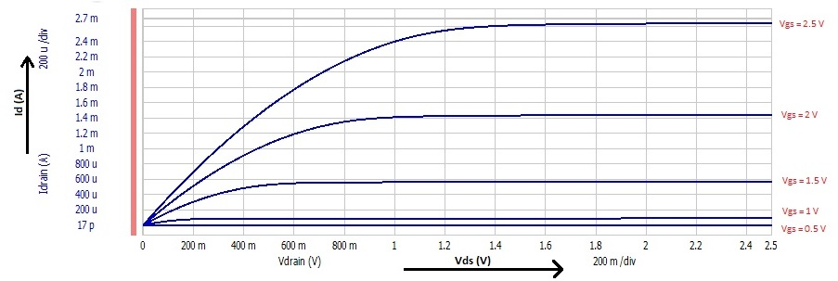

NMOS Short Channel:

