**EE435**

**Experiment 1: Operational Amplifier Parameters Measurement**

**Objective:** The objective of this experiment is to develop measurement methods for characterizing key properties of operational amplifiers

**1 Introduction**

Amplifiers are one of the major components and building block used in analog and mixed-signal circuits. Invariably a wide variety of applications requires meeting rather stringent performance requirements on characterization parameters such as dc gain, gain-bandwidth product (GB), slew rate, offset voltage, etc. In this experiment, these specifications will be measured for both the commercial uA741 operational amplifier and the single-ended push-pull amplifier. A standard CMOS inverter such as a C4004 or a MOS transistor array, the CD 4007, can be used to build the push-pull amplifier. Although these CMOS devices are in old technology, they should work well for this amplifier application.

**2 Performance Parameter Measurements**

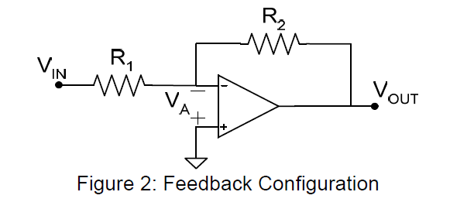

**This circuit can be used to measure DC gain, GB, SR, Settling time, and Overshoot.**

***2.1 DC Gain, Ao***

With this measurement, it is important that the frequency of the input be low enough so that it is well below the 3dB band edge of the operational amplifier. You can simply give a DC input voltage V1 and measure the value of Vout1. Than give another DC voltage V2 and measure the value of Vout2.

DC gain, $A0=\frac{Vout1-Vout2}{VA1-VA2}$

Reasonable values for VDD and VSS might be +3V and -3V respectively.

***2.2 Gain Bandwidth Product GB***

Give a sine wave input to the circuit with a low frequency and observe the output voltage. Then increase the input voltage frequency and at the same time keep checking your output voltage. When the input frequency is high enough to make a 30% drop on the magnitude of the output, this frequency is called the 3dB frequency. A routine calculation shows that if the operational amplifier can be modeled as a single-pole amplifier, then the 3dB bandwidth of the feedback amplifier of Figure 2 relates to the magnitude of the feedback gain K and the GB of the op amp by the equation

Where 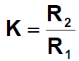 .

***2.3 Slew Rate, SR***

The slew rate is defined as the maximum rate of change of the output voltage.Slew Rate is a large signal concept so the input should be given a large signal. Make sure the ratio of R2 and R1 is big enough so you can observe a steep output. Try the ratio of 10. Give a step input with a large size and measure the slew rate.

***2.3 Overshoot and settling time.***

Maximum overshoot is defined as "the maximum peak value of the response curve measured from the desired response of the system. Overshoot is a small signal concept so make sure you give a small signal into the input. The following plot will give you a better idea about SR and Overshoot.

Note: Please use the same tolerance of 1%.

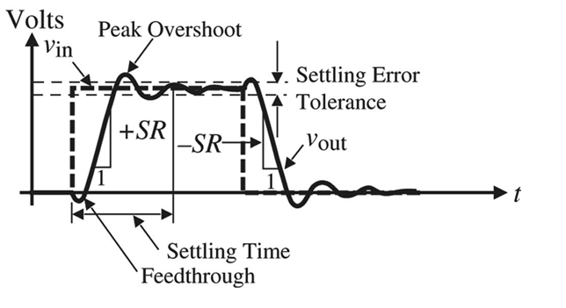

***2.3 Offset Voltage, VOS***

Use the following circuit to measure the input-referred offset voltage for four different 741 operational amplifiers and comment on how these offset voltages compare.

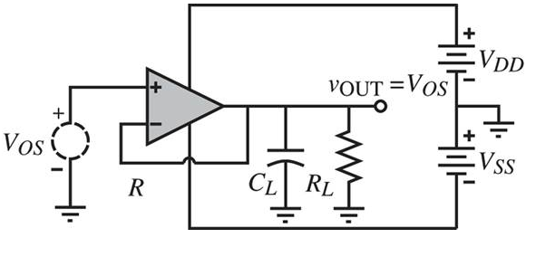

The offset voltage of an op amp is a random variable and can take on either positive or negative values. It will also vary from device to device. The designer goes to considerable effort when designing an op amp to make the offset voltage is small but inherent process variations from device to device will make it impossible to eliminate the offset voltage. The offset voltage can be modeled with a single dc voltage source in series with an input terminal of the op amp as shown in the circuit. In this circuit, the input signal voltage is still zero but the presence of the offset voltage will cause the output voltage of the feedback amplifier to be non-zero. A resistor ratio of 100 or even 1000 is useful for easily and accurately measuring the offset voltage.