HW 1

- Go to the MOSIS web site and find the parameters for the ON 0.5 process corresponding to those given in Table 1.3.
.
- In Lab 1, you studied the feedback op amp circuit below. 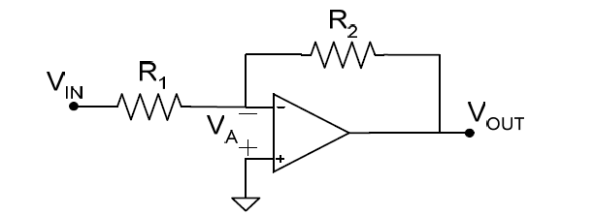
The same circuit can be conceptually represented in the form:

Derive the expressions for α, β, and A in terms of R1, R1, and Av, where Av is the gain from V_{A} to V_{out}.. If Av = A₀/(1+s/p), what is the open loop GBW? Find the closed loop transfer function A_{vc}=V_{out}(s)/V_{in}(s). Find the closed loop DC gain, -3 dB bandwidth, and GBW.

- 1.9
- 1.11
- 1.14
- 1.17
- 1.19
- 2.12
- 2.13
- 2.14

