HW 2

- The circuit below was shown in class. Assume the circuit has been well designed, with the correct biasing so that all transistors are in saturation at quiescent. The signals labeled are small signals away from the quiescent values. Draw the small signal model, obtain r_{o} and A_{v}, and show that with appropriate k, we can make r_{o} and A_{v} infinity. Optional: how do you implement the feedback?
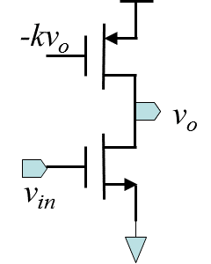
.
- The following is a common gate amplifier. At the input, proper circuit must be provided for the quiescent current to flow. Suppose the current source has output resistance R_{L}. Plot G_{in}, A_{v}, and G_{in}*A_{v} as a function of R_{L}. Find the peak values and the corresponding R_{L}’s.
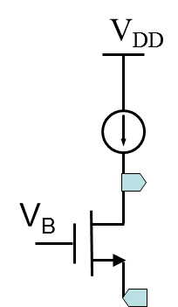

- 3.7
- 3.11
- 3.14
- 3.17
- 3.22
- 3.23
- 3.25
- 3.32

