HW 3

- Shown below is a generic fully differential folded cascode amplifier. Suppose all transistors are reasonably well designed. The two transistors in each pair are identical. V_{b1}, V_{b5}, and V_{b2} are appropriately selected so that total current at the bottom is equal to the total current at the top. All transistors are supposed to be in strong inversion with V_{eff} in the 0.1 to 0.4 V range, and all need to be in saturation.
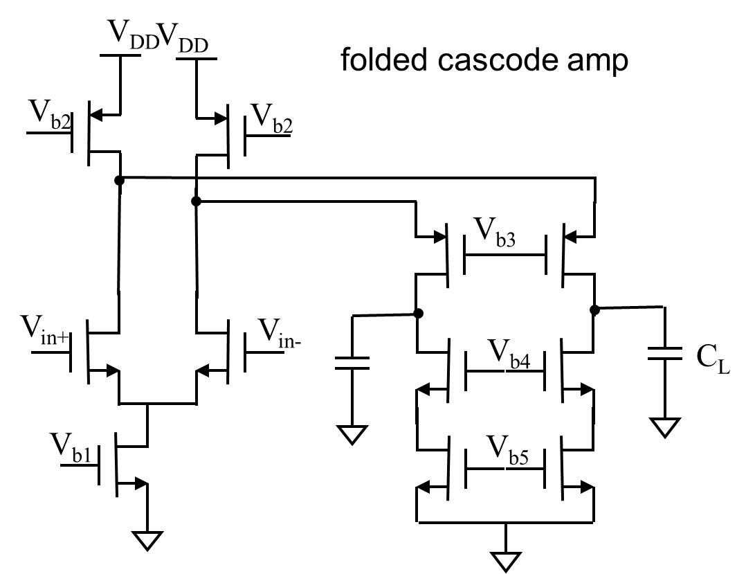
  - Find conditions on V_{b3} and V_{b4}.
  - Find output swing range for V_{o+}, V_{o-}, and V_{od}, first in terms of V_{b3} and V_{b4}, and then the largest possible range.
  - Find the input common mode range.
  - Find the positive and negative slew rate for V_{o+}, V_{o-}, and V_{od}.

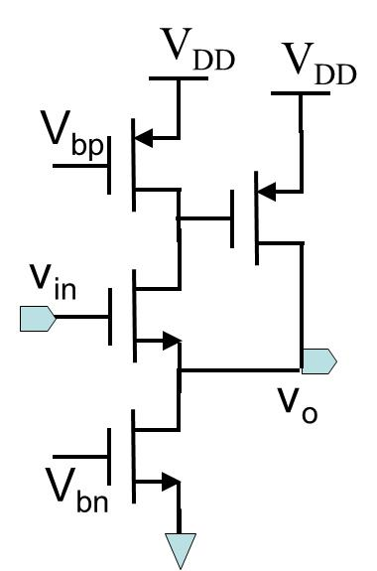
- For the circuit shown to the right. Suppose the two PMOST have the same size and the two NMOT have the same size. V_{bn} and V_{bp} are well selected.
  - Find the I_{DQ} relationships and V_{eff} relationships among all transistors.
  - Find V_{in} range and V_{o} range. (notice that their difference is about fixed)
  - Find r_{in}, r_{o}, and A_{v}(0).

- 4.4
- 4.8 (assume constant numerator)
- 4.12 a. but use MOSIS 0.5um parameters
- 4.14 a. but use MOSIS 0.5um parameters
- 4.20
- 4.21
- 4.26
- 4.27

