HW 4

- Shown below is a two stage op amp with differential input and single ended output. The first stage is a self-biased telescopic cascode structure and the second stage is a common source amplifier. All transistors must be in saturation. C_{L} = 2pF. I_{ref} = 10 μA and is given. V_{DD} = 5V, V_{SS} = 0V and desired V_{oQ} = 2.3V. Desired output swing range is +-2V around V_{oQ}. Slew rate must be greater or equal to 50 MV/sec. GBW must be >= 30 MHz. When connected in a buffer connection, the small signal step response over shoot should be <= 25%.
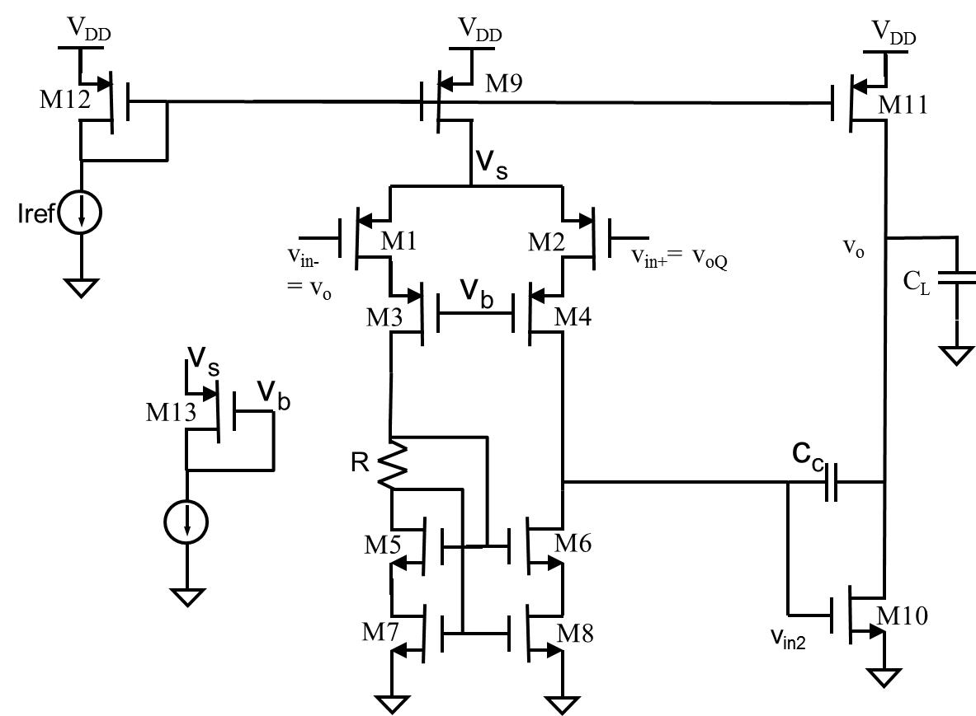

  - Find constraints on V_{eff10} and V_{eff11}, and select target values for these. What V_{eff} should you target for M9 and M12?
  - During V_{o} up slewing, what capacitors needs to be charged? Determine I_{11Q} to ensure that SR+ can reach the desired level. Suppose Cc = 3/4 pF is used. Hint: you can think of Vo1 to be approximately unchanged during this time.
  - With the target V_{eff} and quiescent current, size M11 and M12.
  - In the single-stage common source amplifier, the GBW is equal to g_{m}/C_{Ltot}. When the common source amplifier is used as the second stage with Cc compensation, the whole op amp’s GBW is limited to only about half of g_{m}/C_{Ltot}. Find the minimum gm needed for M10 and use this information to size M10. Use the square law model to find V_{in2Q}, which is also V_{o1Q}.
  - In order to be able to turn off M10 during Vo up slewing, Vo1 must be able to go at least as low as Vt. At this point M6 and M8 should still be in saturation. Use this condition to budget Veff for M6 and M8. Be sure to leave about 0.1V extra room.
  - During the Vo up slewing, the current going into Cc come from M11, but the current coming out of Cc has to go through M6 and M8. So the maximum current in M6 and m8 must be sufficient to support this. But as we learned before, the maximum current in M6 and M8 is when M2 is turned off and all the tail current in goes through M1, M3, M5, M7, and by current mirror, through M6 and M8. Use this information, the size of Cc, and SR+ to compute the I9Q. What will be the quiescent current in M1 to M8?
  - Size M9.
  - Use the quiescent current and the Veff budget in part e to size M8. You can make M5 to M8 all equal. Compute the gate voltage at G8 and G6.
  - Determine the right value for R.
  - As shown, the overall gain-bandwidth production of the op amp is given by gm1/Cc. Find the designed gm1 and size M1 to M4.
  - Select a small current (eg Iref) for M13 and size M13 to ensure that M1 and M2 are in saturation.
  - With your design, find the input common mode range.

- 5.2
- 5.4
- 5.8
- 5.12

