HW 5

- Shown below is a fully differential two stage op amp. The first stage is a folded cascode structure to increase ICMR. The second stage consists of a pair of common source amplifiers. Lead compensation is shown. All transistors must be in saturation. Desired V_{oQ} = V_{DD}/2.
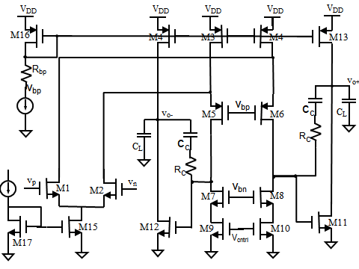

  - Suppose I_{ref} is given. Which transistors set the current levels? These are the secondary sides of current mirrors and should have larger V_{eff} for better robustness.
  - How is V_{o+} swing range related to V_{eff13} and V_{eff11}, what is the achievable V_{od} swing range?
  - Find the expression for V_{bp} in terms of M16 and R_{bp}. Find conditions on R_{bp} to ensure that M3 and M4 are in saturation and “comfortably” in saturation.
  - Find ICMR for a given V_{bp}, and for a V_{bp} that puts M3 and M4 just about “comfortably” in saturation.
  - For given V_{eff11} and V_{eff10}, find the conditions on V_{bn} and V_{eff8} to ensure that both M8 and M10 are “comfortably” in saturation. Pick a suitable V_{eff8}, find the range for V_{bn}, and then choose V_{bn} to be at the middle of its range.
  - In class, we talked about generating by placing a resistor on top of the diode connected M17. Describe and quantify how to do this to realize your choice in part e.
  - Show that the gain of the first stage is g_{m1}*r_{o1}, with r_{o1} = r_{o1p}|| r_{o1n}, r_{o1p} = (r_{ds4}||r_{ds1})A_{v6}, and r_{o1n} = r_{ds10}A_{v8}. Find the expressions for A_{v6} and A_{v8} in terms of their quiescent current and size. Explain how you can use these to select the folded cascode current and the cascode transistor size to influence the amplifier gain.
  - In g, for what values of currents do you need to insert diode connected transistors between gate and drain of M3 and M4. Use your own words to explain the reason. (There is explanation in the book.)

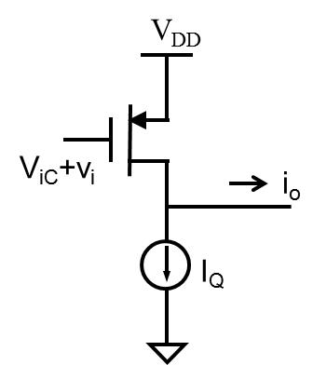
- In Dr. Xicheng Jiang’s presentation on Wednesday, he described several versions of gm cells, with progressively better linearity.
  - Suppose I_{Q} is ideal and selected so that when v_{i} = 0, i_{o} = 0. Use square law model to find the expression of i_{o} in terms of v_{i}. Is it linear of nonlinear? Explain why V_{ic} has to be constant and accurate.

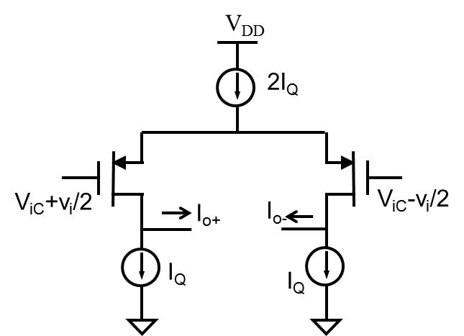
  - Now consider the differential case. Suppose all current sources are ideal. Let the voltage at the cross source point be denoted Vs. Use square law model. Find the expression of i_{o+} - i_{o-} in terms of v_{i}. {Note that i_{o+} - i_{o-} = i_{d1} – i_{d2} and x²-y²=(x+y)(x-y). } Is the relationship linear or nonlinear? Does Vic variations affect the relationship? (Be careful with your answer.)
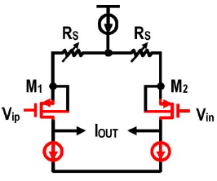
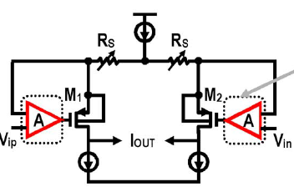
  - In real cases, the expression of i_{o+} - i_{o-} in b will not be right and will become nonlinear. What non-idealities will cause nonlinearity? Another drawback is that v_{i} range is very small.
  - What main advantages does source degeneration bring?

  - Explain why adding the amplifier helps with linearity?
(For part d and e, try to read the corresponding section of the paper and use your own words to provide the answer.)

- 6.33
- 6.43
- 6.54
- 6.56

