EE 475 Fall 2006 Midterm Exam #1
Name
Instructions:
- This is a closed-book and closed-notes exam for individual work. You may have one sheet of formulae of size no larger than US letter. Calculator is not allowed.
- Time for the exam is 50 minutes.
- Do all problems. Each problem is worth 10 points, for a total of 80 points.

Problems:

- Given an LTI system with transfer function H(s) = 2/(s+2), find the time-domain output response y(t) due to an input x(t) = unit step function.

- Given an LTI system G(s) = 10/(s+1)^2, if the input is sin(t), will the output converge to a sinusoidal signal as t becomes large? If not, explain why not. If yes, compute the steady state output sinusoidal response.

- Find the transfer function from R toY:
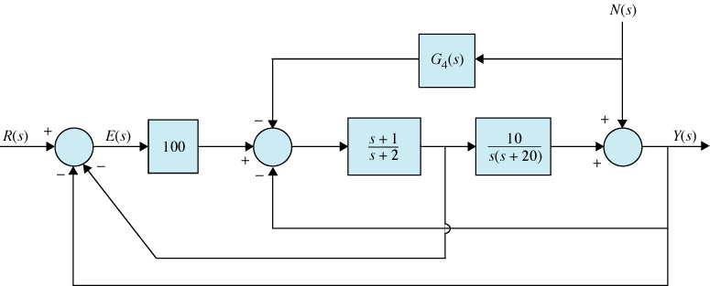

- Consider the signal flow graph:
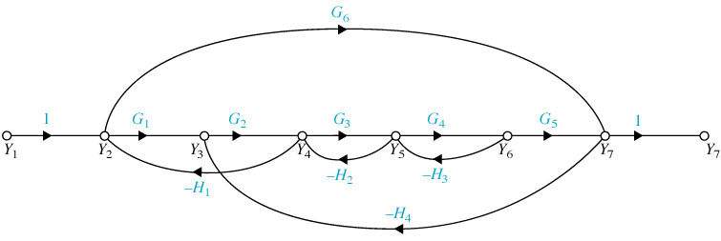
  - Name all forward paths and give the forward path gains
  - Name all loops and the loop gains
  - Name all non-touching pairs of loops
  - Find the transfer function fromY1 to Y5.

- Given the circuit below. v is input and vL is output. Derive the state space model for the circuit and write it in the standard form.
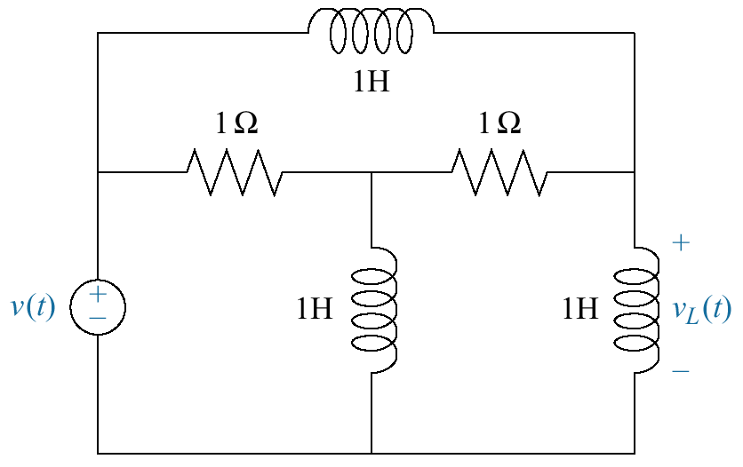

- Given xdot = Ax + Bu; y = Cx; with A=[0 1 0; 0 0 1; 0 1 0]; B=[0; 0; 1]; C=[1 1 0]. Determine the controllability and observability of the system.
- For the state space model in the above system, compute the input to output transfer function and find its zeros and poles.

- For the system in problem 6, find the characteristic polynomial of the system; compute all eigenvalues; and compute the eigenvector corresponding to the most negative eigenvalue.

