EE 475 Fall 2006 Midterm Exam #2
Name
Instructions:
- This is a closed-book and closed-notes exam for individual work. You may have one sheet of formulae of size no larger than US letter. Calculator is not allowed.
- Time for the exam is 50 minutes.
- Do all problems. The points for each problem are marked. 100% is 100 points. There are also 5 bonus points included.

Problems:

- A system has characteristic polynomial d(s) = s^4 + 9s^3 + 45s^2 + 87s + 50.
  - Use Routh-Hurwitz criteria to determine the number of roots of d(s) that are in the left half complex plane, the right half plane, or on the jω-axis. (5 points)
  - Determine the internal stability and input-output stability of the system. (5 points)

- A completely controllable and completely observable system has characteristic polynomial d(s) = s^5 +s^4 +4s^3 + 24s^2 + 3s + 63.
  - Use Routh-Hurwitz criteria to determine the number of eigenvalues of the system’s A-matrix that are in the left half complex plane, the right half plane, or on the jω-axis. (5 points)
  - Determine the internal stability and input-output stability of the system. (5 points)

- Consider the system below and let p=0.
  - Obtain the closed-loop transfer function. (5 points)
  - Use Routh-Hurwitz criteria to determine conditions on K and z so that the system is stable. (5 points)
  - Determine all possible conditions on K and z so that the system will have sustained oscillation. Find the oscillation frequency. (10 points)

- For the system in problem 3,
  - Find the system type with respect to the reference input. (2 points)
  - Find the position error constant, velocity error constant, and acceleration error constant. (6 points)
  - Find the steady state tracking error due to a constant reference, steady state error if the reference input is of the form 5t, and the steady state error if the reference input is of the form 5t². (6 points)

- Consider the following system and assume that parameters are selected so that closed loop system is asymptotically stable.
  - Determine the system type with respect to r, system type with respect to d1 and system type with respect to d2. (6 points)
  - Find the individual steady state tracking error component due to a unit step d1, a unit ramp d2, a unit acceleration signal r, and the total steady state tracking error. (10 points)
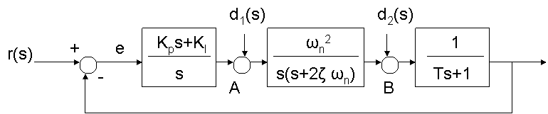
- For the system given below, estimate the values of K and Kt so that a maximum percentage overshoot of 9.6% and a settling time of 0.05 sec for a tolerance band of 1% are achieved. (10 points)

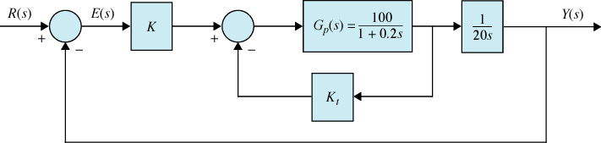

- The step response specifications for a system are given: 1) overshoot <= 16%, 2) settling time for 2% tolerance band <= 1sec, 3) peak time <= 0.5 sec, 4) rise time <= 0.3 sec. (15 points)
  - Find approximate conditions on ζ and ω_{n}.
  - Estimate and sketch the desired region for the pole location in the s-plane.

