EE 475 Fall 2007 Quiz #2
Name:

- Let Y(s) = $\frac{s+1}{s(s+3)}$, find the initial value y(0): ;
- and the final value y(∞): ;
- Given: , y/x = ;
- Given: , y/x = ;
- Given: , y/x = ;
- Given: , s = ;
- which is equivalent to 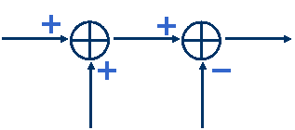 (please label x, y, z, or s on graph);
- and also equivalent to 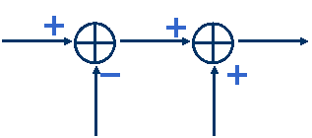 (please label x, y, z, or s on graph);
- Draw an equivalent block diagram to that in 4 above by moving the G1 block across the summing junction:

- Draw an equivalent block diagram to that in 5 above by moving the G1 block across the summing junction:

