EE 475 Fall 2007 Quiz #3
Name:

Given the following block diagram:
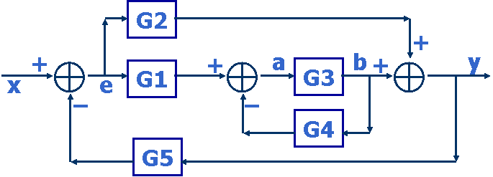
- Obtain the equivalent signal flow graph by completing the following graph

- There are two forward paths. One has gain M1 =
- The other has gain M2 =
- The determinant corresponding to M1 is Δ1 =
- The determinant corresponding to M2 is Δ2 =
- There are three loops. The one involving G1 has gain L1 =
- The loop involving G2 has gain L2 =
- The loop involving G4 has gain L3 =
- The determinant of system is Δ =

- The transfer function from x to y is =

