EE 475 Fall 2008 Midterm Exam #2

Instructions:
- This is a closed-book and closed-notes exam for individual work. You may have one sheet of formulae of size no larger than US letter. A scientific calculator is allowed.
- Time for the exam is 50 minutes. Do as many problems as you can.
- Each sub-question or each blank is worth 1 point, unless otherwise marked.

Problems:

- For the following closed loop transfer functions, determine whether the system is marginally stable, asymptotically stable, or unstable. (no pole/zero cancelation happened)
a) $M(s)=\frac{5s^{2}+6s+3}{(s+2)(s−2)}$ :
b) $M(s)=\frac{(s−3)(s+4)}{(s+2)(s+5)}$ :
c) $M(s)=\frac{\text{10}s^{2}+6s+1}{s(s+\text{100})}$ :
d) $M(s)=\frac{(s+1)}{s^{2}(s+2)}$ :
- Given a system characteristic polynomial d(s)=s⁴+5s²+20s+104. Construct the Routh table.
- After you are done, the first column elements are: 1, , , , 104.
- The number of roots in the RHP, the LHP, and on the jw-axis are , , .

- Given a system characteristic polynomial d(s)=s⁴+2s³+9s²+8s+20. Construct the Routh table.
- After you are done, the first column elements are: 1, 2, , , 20.
- During the process, you obtained an auxiliary polynomial A(s) = .
- Determine if the system is asymptotically, or marginally stable, or unstable: .
- If the system admits sustained oscillation, what is the oscillation frequency: .

- Determine the step, ramp, and parabolic error constants of the following unity-feedback control systems. The forward-path transfer functions are given. Assume the closed loop systems are stable.
a) $G(s)=\frac{\text{50}}{(1+s)(1+\text{20}s)}$
K_{p}= , K_{v}= , K_{a}
b) $G(s)=\frac{2}{s(s+1)(s+2)}$
K_{p}= , K_{v}= , K_{a}
c) $G(s)=\frac{5s+1}{s^{2}(s^{2}+5s+6)}$
K_{p}= , K_{v}= , K_{a}

- Given the system shown below. Hand sketch the root locus as K varies from 0 to +∞.
  - Hand sketch the root locus as K varies from 0 to +∞.
  - Write the standard Root Locus equation for this problem .
  - Open loop poles are and finite zeros are .
  - How many asymptotes are there: , what are their angles: , where do they meet: .
  - The breakaway point is approximately located at: .

+

- Sketch the s-domain region that corresponds to the following design specifications.
- Percent overshoot ≤ 5%
- Rise time ≤ 1.8 seconds
- Settling time ≤ 8 seconds, for tolerance = ±2%
- Indicate your first choice for the dominant pole location.
- If after the design, you find that the rise time is too long, how would you move the dominant pole in the redesign? And why? (2 pts)

- For the polynomial d(s) = s^4 +6s^3 + 11s^2 + (K+6)s + A, (10 pts)
  - construct the Routh table,
  - provide inequality constraints for K and A so that the polynomial is stable,
  - graph the constraints in the K-A parameter space,
  - determine the parameter values at which the system will have sustained oscillation,
  - Find the oscillation frequency.

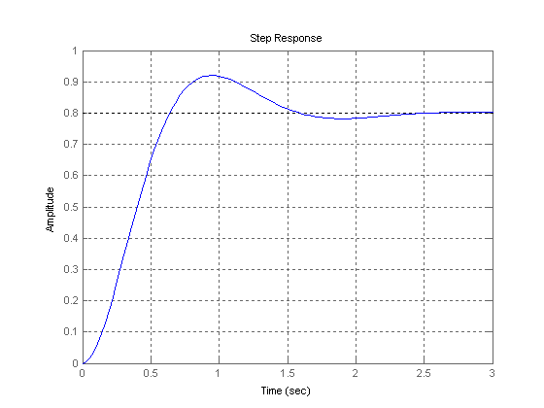
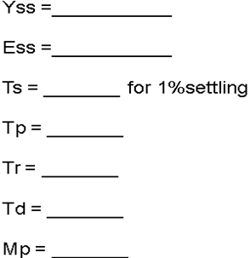
- For the following step response plot, estimate the indicated values.

- The following systems are of the form

G(s)
G(s)

The root locus plots for different G(s) are shown below. Answer the following questions:

- G(s)=. What type of controller is needed to achieve a settling time ≤ 2 seconds with a tolerance of ±1%? Explain your answer. (5 pts)

- G(s) = . What type of controller would be best to use to achieve an overshoot ≤15%? Explain your answer. (5 pts)

- What type of controller would be to use to change a non-zero steady state tracking error to a 0 steady state tracking error? Why? (5 pts)

- For the system given below, estimate the values of K and T, so that a maximum percent overshoot of 16% and a settling time of 0.1 sec for a tolerance band of 1% are achieved. (10pts)
K

G(s) = 100
1+T*s
_1_
20s
_{0.1}
R(s)
Y(s)

- Given the following prototype 2nd order systems, answer the following question.

- ___4__ b) __1___ c) ___16___ d) __9____
s²+2s+4 s²+s+1 s²+4s+16 s²+3s+9

Which system’s transient decays the slowest? a b c d

Which system has the lowest percent overshoot? a b c d

Which system has the shortest rise time? a b c d

Which system has the shortest peak time? a b c d

Which system has the shortest settling time? a b c d

Which system has the smallest ess to ramp? a b c d

Which system has the largest ess to ramp? a b c d

Which system has the slowest oscillation? a b c d

Which system has the least pole magnitude? a b c d

Which system has the least damping ratio? a b c d

- In a control system design problem, it has determined that the desired dominant pole should be placed at pd = - 5 + j*5rt(3). At this location the plant transfer function value is -1+j*rt(3). Design a lead controller using the bisection method to achieve the task. (10 pts)

