EE 475 Midterm Exam 1, Fall 2009
Name:
- Find the unit impulse response of a system whose transfer function is given below.
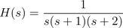

- The closed-loop transfer function of a zero-less second order system is of the form:
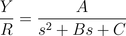
The unit step response of this system has steady state error ess = 0.1 and the response peak value is 1.05 which happens at t = 0.1 second. Find A, B, and C.

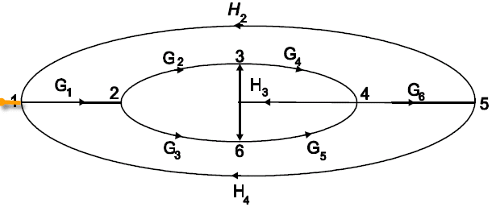
- Consider the signal flow graph given above. Let the left most node be the input and node 5 be the output. List the 2 forward path gains, list the 6 loop gains, and find the determinant of the graph. There is no non-touching pairs.

- Consider a control system given in the following block diagram:
+
C(s)
G(s)
_

where C(s) = (s-1)/s, G(s) = 4/{(s+4)(s-1)}. Is the system BIBO stable?

- Consider a control system given in the following block diagram:

D1(s) D2(s)
R(s) + E(s) + + Y(s)
C(s)
1/(s+1)
1/s

_ + +

where C(s) = (s + z )/(s + p), with z>p>0. What are the system types with respect to R, D1, or D2, respectively? For zero steady state error, what kind of R, D1, and D2 can be tolerated?

- For the control system given the previous problem, let z>0. How should p be selected so that the system can track a ramp input R with no steady state error? What condition on z needs to be maintained?

- Find the transfer function from u to y for the following state space model:

- A state space model is given below. Find the characteristic equation and determine the system’s internal stability and BIBO stability.

- Determine if the following characteristic polynomials are AS, MS or unstable. Give your answer and a brief reason for each case. (1 point each)

- Find conditions on k and a so that d(s) = is asymptotically stable.

- Consider the step response of a prototype second order system. Draw the desired region of closed-loop pole location in the complex plane corresponding to t_{p} < 1 second and t_{s} < 2 for 2% tolerance, and overshoot < 5%.

- A system has step response given by 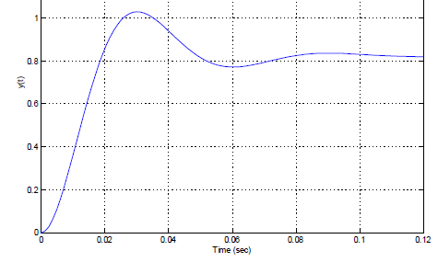
If the input to the system is a ramp, what is the steady state error? Find the Kp, Kv, and Ka for the system.

- If the system in the previous problem is a zero-less second order system. Find the transfer function of the system.

- A simplified model of an operational amplifier is given by: 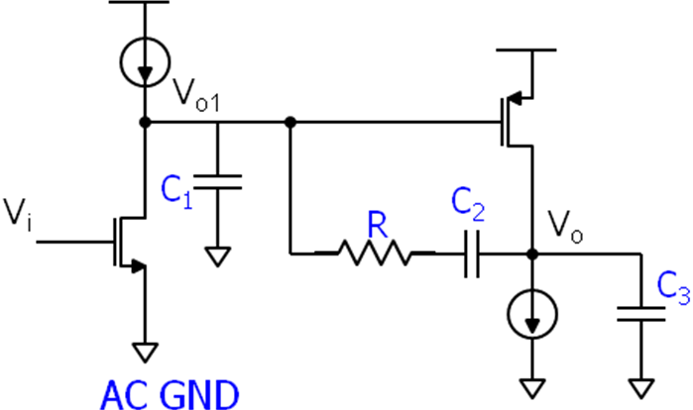
For small signal analysis, the current sources can be viewed as open circuit. For each transistor, the current into the gate is 0, the current through the transistor is its gm times the gate voltage, and the current direction is from Vo1 into the transistor or from Vo into the transistor respectively. Write two KCL’s at node Vo and Vo1, and find the transfer function from Vi to Vo. (10 points)

