EE 475 Fall 2009 Quiz #3
Name: Solution

- If h(t) is the impulse response of a system, the system is BIBO stable iff is finite .
- Assume no pole/zero cancelation. A system is A.S. if its poles all have negative real parts .
- a*s² +b*s+c is A.S. if a, b, c all have the same sign .
- a*s³ +b*s²+cs+d is A.S. if a, b, c, d all have the same sign and b*c > a*d .
- G1*G2
- 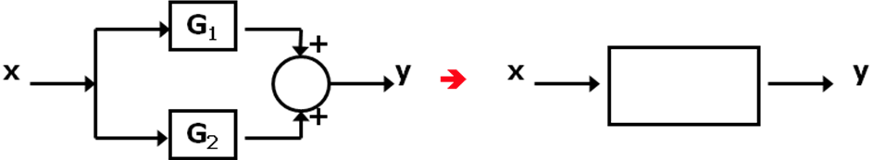G1+G2
- 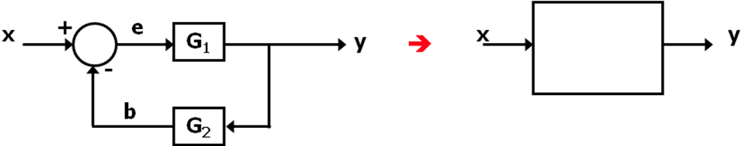G1/(1+G1G2)
- 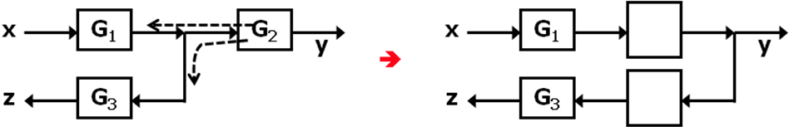G₂, and 1/G₂

