EE 475 Fall 2009 Quiz #4
Name: Solution

- Assume no pole/zero cancelation. A system is A.S. if its poles all have Re<0 .
- a*s² +b*s+c is A.S. if a, b, c have the same sign .
- a*s³ +b*s²+cs+d is A.S. if a, b, c have the same sign and b*c > a*d .
- 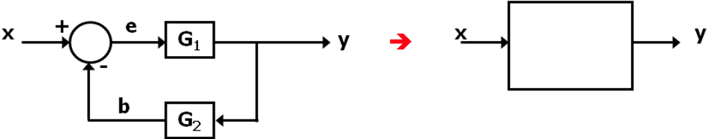G1/(1+G1G2)
- 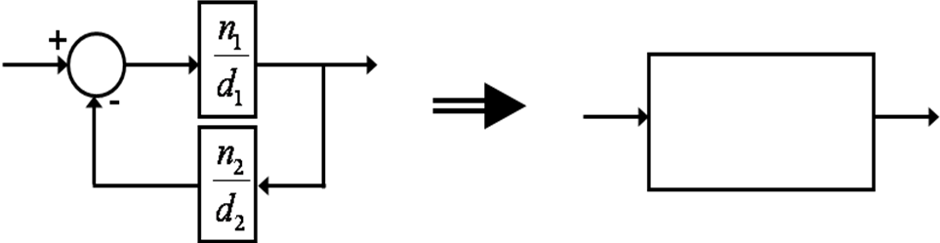n1d2/(n1n2+d1d2)
- 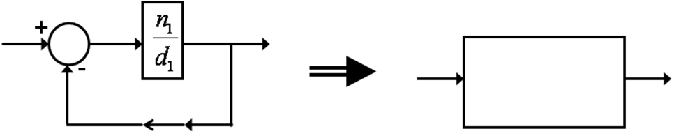n1/(n1+d1)
- For the block digram below
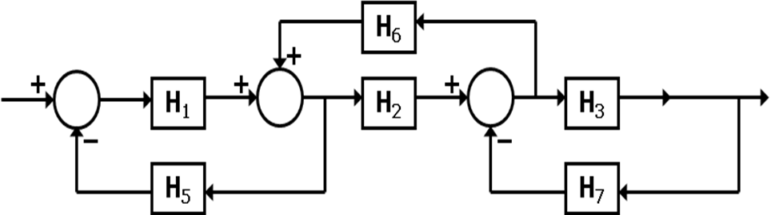
- List the forward path gains: H1H2H3 .
- List the loop gains: -H1H5, +H2H6, -H3H7 .
- List the non-touching loop pair’s gain product: H1H3H5H7 .
- The determinant of the graph is Δ= 1+H1H5+H3H7-H2H6+H1H3H5H7 .

