EE 475 Fall 2009 Quiz #4
Name:

- Assume no pole/zero cancelation. A system is A.S. if its poles .
- a*s² +b*s+c is A.S. if .
- a*s³ +b*s²+cs+d is A.S. if .
- 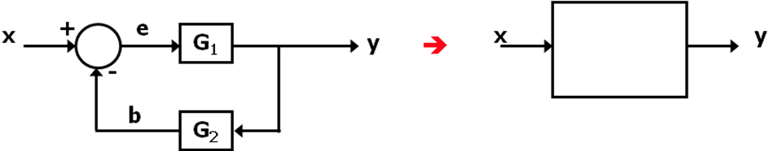
- 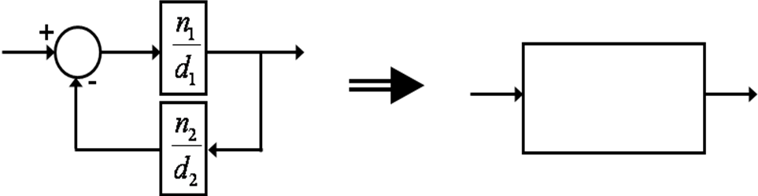
- 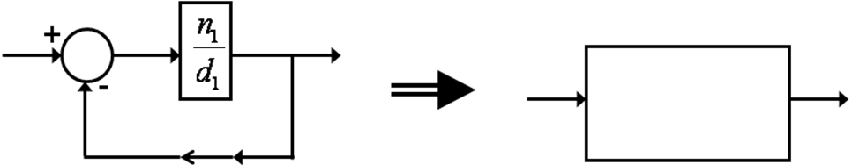
- For the block digram below
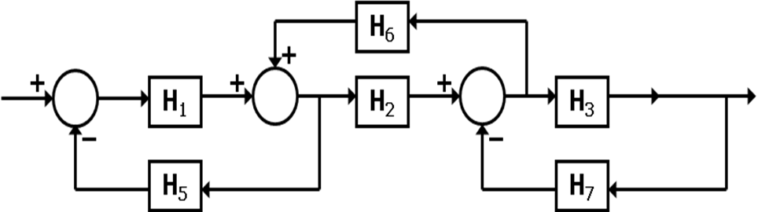
- List the forward path gains: .
- List the loop gains: .
- List the non-touching loop pair’s gain product: .
- The determinant of the graph is Δ= .

