EE 475 Fall 2009 Quiz #5
Name: Solution

- A state space model is A.S. if the A matrix’s eigenvalues all have real part < 0 .
- A transfer function is BIBO stable if All poles have real part < 0 .
- a*s² +b*s+c is A.S. if a, b, and c all have the same sign .
- a*s³ +b*s²+cs+d is A.S. if a, b, c, and d all have the same sign and b*c > a*d .
- 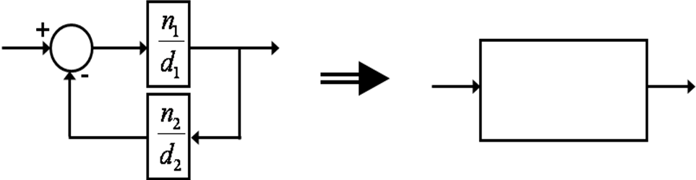n1d2/(n1n2+d1d2)
- 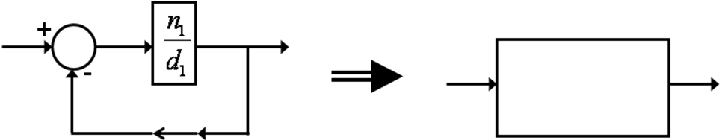n1/(d1+n1)
- For the block digram below
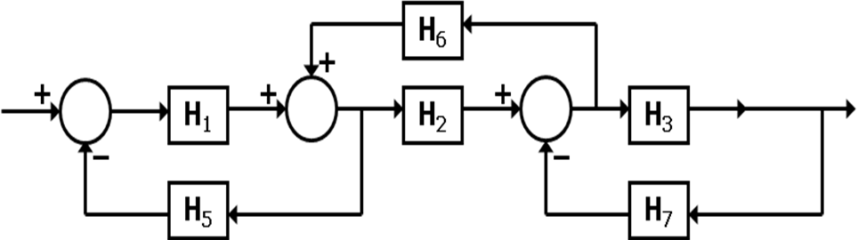
- List the forward path gain M1: H1H2H3 .
- The determinant associated with the forward path is Δ1: 1 .
- If the whole graph’s determinant is Δ, the I/O TF is: H1H2H3/Δ .

