EE 475 Fall 2009 Quiz #7
Name:

- For a unity feedback control system with open loop transfer function G(s), give the definition of:
System type:
Position error constant
Velocity error constant
Acceleration error constant

- Given the system below:
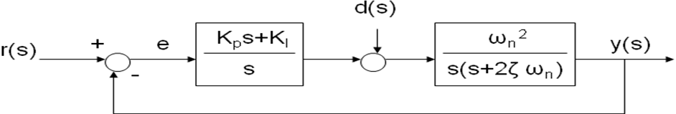
What is the system type with respect to reference input r(s)?
What is the system type with respect to disturbance input d(s)?
What is the steady state error due to a step r(s)?
What is the steady state error due to a ramp r(s)?
What is the steady state error due to a step d(s)?

