EE 475 Fall 2009 Quiz #7
Name: Solution

- For a unity feedback control system with open loop transfer function G(s), give the definition of:
System type: #integrators in G(s) or # factors of s in denominator of G
Position error constant G(0), or b0/a0, or lim of G(s) as s → 0
Velocity error constant sG(s) at s=0, or b0/a1 when a0=0, or lim of sG(s) as s → 0
Acceleration error constant s^2G(s) at s=0, or b0/a2 when both a0 and a1=0, or lim of s^2G(s) as s → 0

- Given the system below:
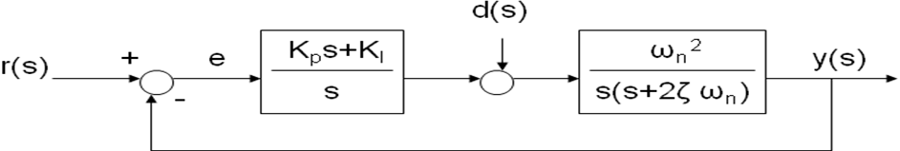
What is the system type with respect to reference input r(s)? 2
What is the system type with respect to disturbance input d(s)? 1
What is the steady state error due to a step r(s)? 0
What is the steady state error due to a ramp r(s)? 0
What is the steady state error due to a step d(s)? 0

