EE 475 Fall 2007 Final Exam
Name
Instructions:
- This is a closed-book and closed-notes exam for individual work. You may have two sheets of formulae of size no larger than US letter. Calculator is allowed.
- Time for the exam is 120 minutes.
- Do all problems. All problems are weighted equally, so do the easier ones first.

Problems:

- Consider a linear control system given by the following state space model.
$\begin{aligned}\overset{˙}{x}=\left[\begin{matrix}−1 & 0 & 0 \\ 0 & −2 & 0 \\ 0 & 0 & −3\end{matrix}\right]x+\left[\begin{matrix}2 \\ 1 \\ 0\end{matrix}\right]u \\ y=\left[\begin{matrix} 1 & −1 & 1 \end{matrix}\right]x\end{aligned}$
Determine the characteristic values (eigenvalues) of the system. Determine if the system is BIBO stable. Justify.

- Without computing the controllability or observability matrices, determine the controllability and observability of the system given in problem 1. Justify.
- Given H(s) = (s-1)/{(s+2)(s²-1)}. Give a new 3rd order state space representation in CCF and another 3rd order one in OCF.

- Convert the following block diagram into signal flow graph. Use the given variables as nodes. List all the loops.
G3
H1h11
G1
G2
G4
H2
y
r
e
+
+
+
+
+
−
−
−

a b c

- Consider the system below and let p=0.
  - Determine conditions on K and z so that the system is stable.
  - Determine all possible conditions on K and z so that the system will be marginally stable.

- Hand sketch the root locus of 1 + KG(s) = 0 as K varies from 0 to +∞, where
$$G(s)=\frac{s+2}{s(s+1)(s+3)^{2}}$$
Make sure you provide verbal description on the following: open-loop pole/zero map; real axis decision; and asymptotes.

- For the system given in problem 6, find the jw-axis crossing point and the corresponding value of K.
- The open-loop Bode plot of unity feedback control system is given.
- Find the gain crossover frequency, phase crossover frequency, gain margin, and phase margin, and mark them on the graph.
- Determine the closed loop stability.
- Estimate the percentage overshoot, settling time, and rise time in the closed-loop unit step response.

- In a unity feedback set-up, the open-loop transfer function G(s) is stable and its Nyquist plot for ω>0 is given below.
- Draw the complete Nyquist plot, label ω=0+, +∞, –∞, 0–, and arrows for increasing frequency.
- Determine the number of encirclement of the “-1” point, the number of unstable closed-loop poles, and the closed-loop stability.
- Make appropriate additions to the Nyquist plot and use these to estimate the gain margin and phase margin.
- The transfer function G of the following system has Bode plot as show below.
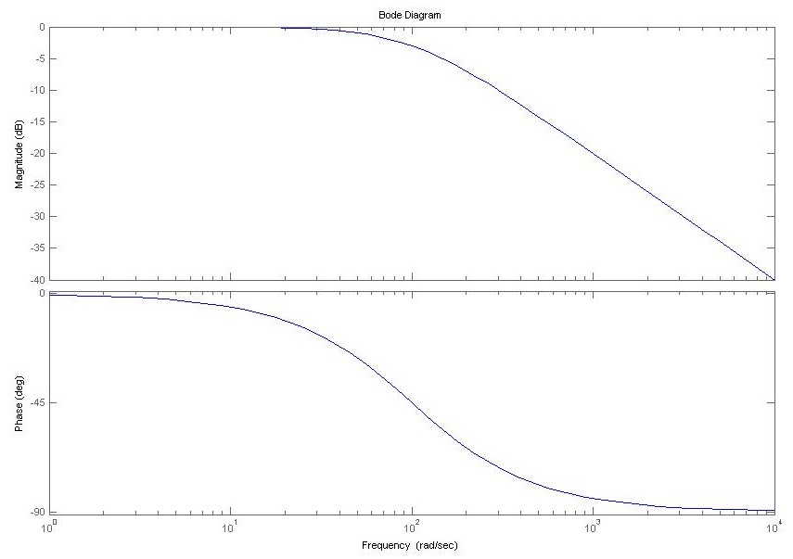
What value for K would make the Ess to unit step approximately 0.09 ? With this K, what would the gain crossover frequency and Phase Margin of the system be?

- A unity feedback system with controller C(s)=1 has root locus shown below. Design specifications are: T_{s} < 2 for a 5% tolerance and overshoot M_{P} < 5%. Draw the desired region for the dominant pole on the graph below and determine the type of controller needed to meet the desired specifications.
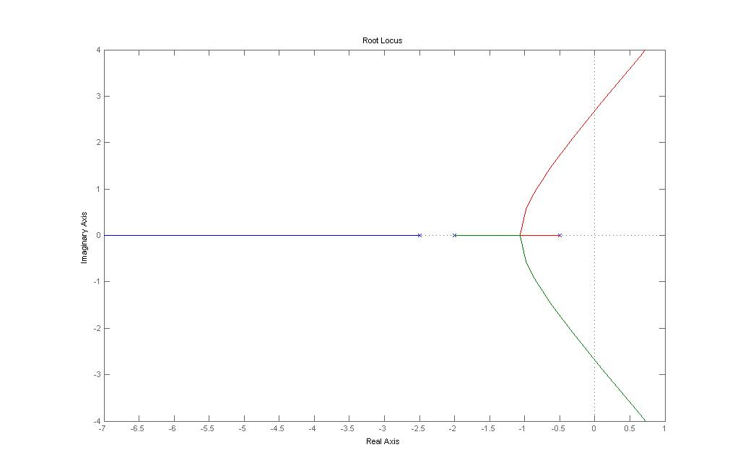

- The forward TF of a unity feedback system is given by the following Bode plot.
Determine the system type and find the steady-state tracking error due to an excitation (5+3t)u(t), where u(t) denotes unit step. Justify your answer

- For each situation below, match the problem with the best controller type.
  - Overshoot is too large, everything else is just about right
    - PD controller
    - Lag controller
    - Low-pass filter
    - PI controller
  - Steady state error must be eliminated, everything else is more than fine.
    - Lead controller
    - Low-pass filter
    - Proportional controller
    - PI controller
  - Phase margin is too low, resulting in a resonance peak that is too high.
    - PI controller
    - Lead controller
    - Low-pass filter
    - Lag controller
  - The closed-loop system is experiencing noise problems at high frequency
    - PD controller
    - Lag controller
    - PI controller
    - Low-pass filter

- An LTI system has a unit impulse response h(t) as shown below. Determine if this system is BIBO stable, and provide reasoning.
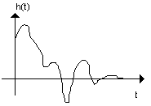

- Let y(t) be the unit step response of a system shown below with$G(s)=\frac{s+5}{s(s^{2}+3)}$.
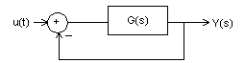
Determine the value of y (t) as t –> infinity.

- Determine the I/O transfer function of the following block diagram.

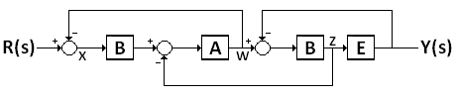

- An LTI system is given by the following state space model
Find the state transition matrix and the transfer function from u to y.

- Compute the controllability matrix or observability matrix to determine if the system is completely controllable or completely observable.
- The closed-loop frequency response is given below. Determine the system’s BW, ω_{r}, and M_{r}. Mark them on the graph.
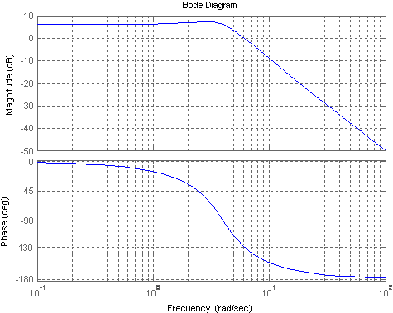

- Find the value of K which makes the following system Marginally Stable.

