EE 475 Fall 2008 Final Exam
Name
Instructions:
- This is a closed-book and closed-notes exam for individual work. You may have two sheets of formulae of size no larger than US letter. A calculator is allowed. Any device with wireless functions must be turned off.
- The official exam time is 9:45 a.m. - 11:45 a.m. on Thursday, Dec. 18.
- Do all problems. All problems are weighted equally, so do the easier ones first.
- Students taking the exam at an alternative arranged time must turn in your exam before 12 pm Dec.25. Scan your exam into pdf and email to djchen@iastate.edu.
===============================================================
Problems 1 to 6 are related to the following block diagram:
- The transfer function from r to y is H(s) =
_______________________________

- If r is a unit step, the steady state error in y is ess = ________.

- If r is a unit ramp, the steady state error in y is ess = ________.

- Is the system BIBO stable? __________

- Give a 3rd order state space equation for the system in the controller canonical form:

- Is the state space model in 5 completely observable?

Problems 7-11 are based on the following graph, which is the closed-loop step response of a control system.

- Determine Mp = ______, t_{p} = _______, t_{d} = ______, t_{r} = _______, and t_{s} = _______ for ±2% tolerance.

- The dominant pole pair of the system must be at p = _____ + j_____; and damping ratio of the pole should be = ______.

- If one had performed the open-loop frequency response and obtained the Bode plot for the open-loop system, the Bode plot would have a gain cross over frequency at ω_{gc} = ______ and a phase margin = ______.

- The slope of the open-loop Bode gain plot at very low frequency is ____ dB/dec. The low frequency portion has an asymptotic line. The value of this asymptotic line at frequency ω = 1 is equal to ______. The Bode phase plot at low frequency will converge to a constant value equal to _______ degrees.

- The closed-loop system’s bandwidth = _____. Will the closed-loop frequency response exhibit a resonance peak? _____. If it does, the estimated resonance frequency = _____. If it does not, why not? ______________________________

Problems 12-15 are based on the following graph which is the open-loop Bode plot of a control system. Assume the open-loop system is stable.
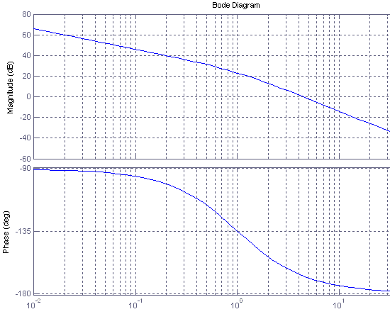

- The system has GM = ______, PM = _______ deg, ω_{gc} =_____, and ω_{pc} = _______.

- If one had constructed the Nyquist plot for the system and applied the Nyquist criterion on the system, one would obtain P = _____, N = ______, Z = ______, and would conclude that the closed loop system stability is _______________.

- If the closed-loop system step response is obtained, one would estimate the rise time is about _____ sec, the overshoot is about _____%, and +-1% settling time should be about _______ sec.

- If the closed-loop system input is given by (3+5t)*u_{s}(t), where u_{s}(t) is the unit step function, the steady state error in the system output is __________.

- Given the Nyquist plots of G(s). Assume G is a strictly proper open-loop TF of a unity negative feedback system and G has no unstable poles. Use the Nyquist criteria, the closed-loop system stability is _______. The gain margin = ______ and phase margin = _______ deg. Find the range that the gain can be changed in order to maintain closed-loop stability. Range ____ to ____. (The unit circle is shown.)

- Consider a control system given in the following block diagram:
+
C(s)
G(s)

_

where C(s) = (s-1)/s, G(s) = 4/{(s+4)(s-1)}. Is the system BIBO stable?

- What is the internal stability of the control system in the previous problem?

19. A unity feedback system with controller C(s)=1 has root locus shown below. Design specifications are: T_{s} < 2 for a 5% tolerance and overshoot M_{P} < 5%. Draw the desired region for the dominant pole on the graph below and determine the type of controller needed to meet the desired specifications.
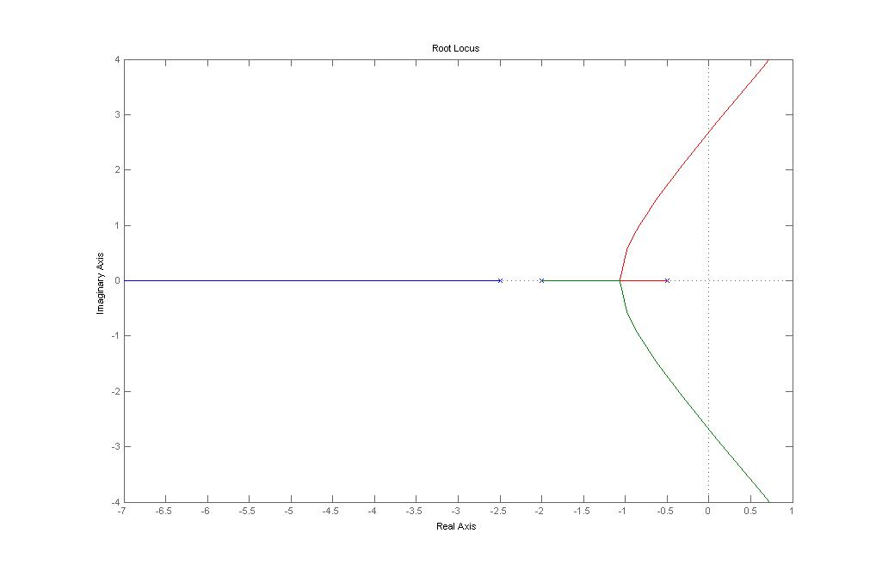

- For each situation below, match the problem with the best controller type.
  - Overshoot is too large, everything else is just about right
    - PD controller
    - Lag controller
    - Low-pass filter
    - PI controller
  - Steady state error must be eliminated, everything else is more than fine.
    - Lead controller
    - Low-pass filter
    - Proportional controller
    - PI controller

