EE 475 Fall 2007 Midterm Exam #1
Name
Instructions:
- This is a closed-book and closed-notes exam for individual work. You may have one sheet of formulae of size no larger than US letter. Calculator is not allowed.
- Time for the exam is 50 minutes.
- Do all problems. Each problem is worth 5 points, for a total of 100 points.

Problems:

- An LTI system has unit impulse response shown below:
2
1
h(t)
t
Find the system’s input output transfer function H(s).

- For the system given in problem 1, determine if the system is BIBO stable.

- The unit step response of the system in problem 1 is given in the s-domain by $y(s)=\frac{1−e^{−2s}}{s^{2}}$. Find the final value y(∞) if it exists.

- For the signal in problem 3, find its initial value y(0).

- A system has transfer function $H(s)=\frac{s−1}{s^{2}−3s+2}$. Find all of its poles and zeros, including those at infinity.

- Is the system in problem 5 BIBO stable?

- At t=0, all variables in the system in problem 5 are zero. After t=0, a bounded input sin(2t) is applied. If the system output settles into a sinusoidal steady state, compute that steady state response. If it does not, describe what happens.

- For the block diagram below, draw the equivalent signal flow graph using 5 nodes: input, output, and one node for each of the 3 junctions.
G1
G2
G3
H1
H2
H3

- Find the input output transfer function for the system in problem 8.

- Identify all non-touching loop pairs in the following signal flow graph and compute the loop gain product for each such pair.
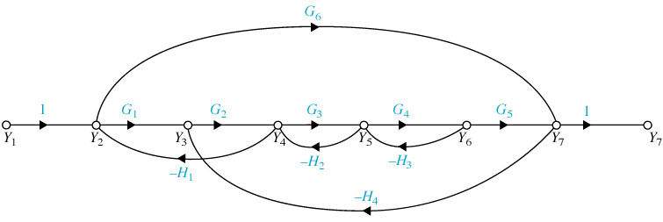

- In the signal flow graph of problem 10, draw the remaining signal flow graph after we have removed the forward path involving G6. Find the determinant D for the graph.

- Given the circuit below. v is input and the voltage y is output. Use the two capacitor voltages as state variables. Derive the state space model for the circuit.

- For the spring mass damper system below, the applied force is input and the position of the mass is output. Develop the input output model in the form of a single ordinary differential equation. Find the input output transfer function.

- Given $\overset{˙}{x}=\left[\begin{matrix}−1 & 0 \\ 2 & −2\end{matrix}\right]x+\left[\begin{matrix}1 \\ 2\end{matrix}\right]u; y=\left[\begin{matrix}1 & 1\end{matrix}\right]x\text{.}$ Find the transfer function from u to y.

- Given $\overset{˙}{x}=\left[\begin{matrix}−1 & 0 \\ 2 & −2\end{matrix}\right]x+\left[\begin{matrix}1 \\ 2\end{matrix}\right]u; y=\left[\begin{matrix}1 & 1\end{matrix}\right]x\text{.}$ Determine if the system is asymptotically stable, or marginally stable or unstable.

- Given $\overset{˙}{x}=\left[\begin{matrix}−1 & 0 \\ 2 & −2\end{matrix}\right]x+\left[\begin{matrix}1 \\ 2\end{matrix}\right]u; y=\left[\begin{matrix}1 & 1\end{matrix}\right]x\text{.}$ Compute the controllability matrix and determine if the system is completely controllable.

- Given $\overset{˙}{x}=\left[\begin{matrix}−1 & 0 \\ 2 & −2\end{matrix}\right]x+\left[\begin{matrix}1 \\ 2\end{matrix}\right]u; y=\left[\begin{matrix}1 & 1\end{matrix}\right]x\text{.}$ Compute the observability matrix and determine if the system is completely observable.

- Given $\overset{˙}{x}=\left[\begin{matrix}−1 & 0 \\ 0 & −2\end{matrix}\right]x+\left[\begin{matrix}1 \\ 2\end{matrix}\right]u; y=\left[\begin{matrix}1 & 1\end{matrix}\right]x\text{.}$ Determine if the system is completely controllable without using the controllability matrix.

- Given $M(t)=\left[\begin{matrix}e^{t} & (e^{t}−e^{−t})/2 \\ 0 & e^{−t}\end{matrix}\right]$. Is M(t) a state transition matrix? If it is, find A such that M(t) = exp(At); if not, explain why not.

- Suppose you are given a system in state space model and the A, B, C, D matrices has been entered in to Matlab numerically. Write the sequence of Matlab commands that you would use to compute the transfer function, the state transition matrix, and the unit impulse response. Details of the syntax can be excused if you describe how you can double check you syntax.

