EE 475 Fall 2007 Midterm Exam #2
Name
Instructions:
- This is a closed-book and closed-notes exam for individual work.
- You may have two sheets of formulae of size no larger than US letter.
- Calculator is discouraged.
- Time for the exam is 50 minutes.
- Do all problems, but easier ones first, since all are equally weighted.

Problems:

- For the system given below, estimate the values of K and Kt so that a maximum percentage overshoot of 9.6% and a settling time of 0.05 sec for a tolerance band of 1% are achieved.

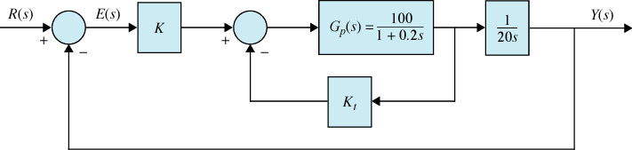

- For the following closed loop transfer functions, determine whether the system is marginally stable, asymptotically stable, or unstable. (no pole/zero cancelation happened)
a) $M(s)=\frac{5s^{2}+6s+3}{(s+2)(s−2)}$ :

b) $M(s)=\frac{(s−3)(s+4)}{(s+2)(s+5)}$ :

c) $M(s)=\frac{\text{10}s^{2}+6s+1}{s(s+\text{100})}$ :

d) $M(s)=\frac{(s+1)}{s^{2}(s+2)}$ :

- Using the Routh-Hurwitz criterion, determine the number of roots of each polynomial that are in the open right half plane.
a) $d(s)=s^{4}+s^{3}+6s^{2}+2s+1$

b) $d(s)=2s^{4}+s^{3}+4s^{2}+5s+\text{12}$

- Determine the step, ramp, and parabolic error constants of the following unity-feedback control systems. The forward-path transfer functions are given. Assume the closed loop systems are stable.
a) $G(s)=\frac{\text{50}}{(1+s)(1+\text{20}s)}$

K_{p}= , K_{v}= , K_{a}

b) $G(s)=\frac{2}{s(s+1)(s+2)}$

K_{p}= , K_{v}= , K_{a}

c) $G(s)=\frac{5s+1}{s^{2}(s^{2}+5s+6)}$

K_{p}= , K_{v}= , K_{a}

- For the systems in the above Problem, find the steady state error values due to a unit step input, a unit ramp input, and a unit acceleration input.

a) ess_step = , ess_ramp= , ess_acc=

b) ess_step = , ess_ramp= , ess_acc=

c) ess_step = , ess_ramp= , ess_acc=

- Given the following prototype 2nd order systems, answer the questions below.
a) $\frac{\text{400}}{s^{2}+\text{20}s+\text{400}}$ b) $\frac{\text{1600}}{s^{2}+\text{40}s+\text{1600}}$
c) $\frac{\text{100}}{s^{2}+\text{10}s+\text{100}}$ d) $\frac{\text{900}}{s^{2}+\text{20}s+\text{900}}$

Which system’s transient decays the fastest? a b c d

Which system has the highest percent overshoot? a b c d

Which system has the longest rise time? a b c d

Which system has the longest settling time? a b c d

- Sketch the s-domain diagram that corresponds to the following specifications for a prototype 2nd order system.
a) Percent overshoot less than or equal to 5%
b) Rise time less than or equal to 1.8 second

- Sketch the s-domain diagram that corresponds to the following specifications for a prototype 2nd order system.
a) Percent overshoot less than or equal to 5%
b) Settling time less than or equal to 4 second (tolerance band is ±2%)

- Sketch the s-domain diagram that corresponds to the following specifications for a prototype 2nd order system.
a) Settling time less than or equal to 10 second (tolerance band is ±2%)
b) Peak time less than π seconds

- Given the forward-path transfer function of a unity-feedback control system, quickly sketch the root locus for K ≥ 0. Do not calculate the jw-axis crossings or departure/arrival angles. Approximately locate any breakaway points.

$$G(s)=\frac{K(s+3)}{(s+1)(s+2)(s+4)(s+5)}$$

- Using the Routh-Hurwitz method find the values of K that make the system stable, the value of K that yields sustained oscillation, and the oscillation frequency.

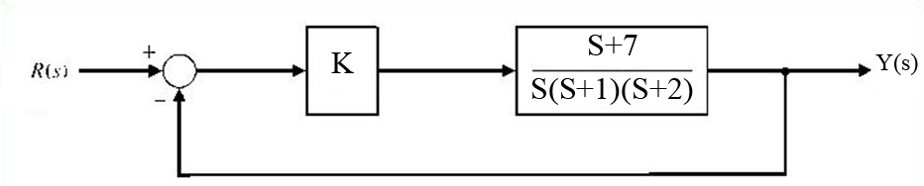

- Sketch the root locus of the system in the previous problem for K>=0. Make sure your real axis and asymptotes are correct. Estimate breakaway points.

- When K = 10, the system below is stable and the steady state error due to ramp input is 0.5. Find the range of K which results in the system being asymptotically stable.

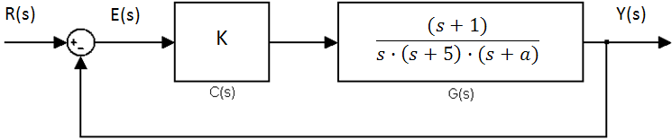

- The step response of a second-order prototype system is plotted below.
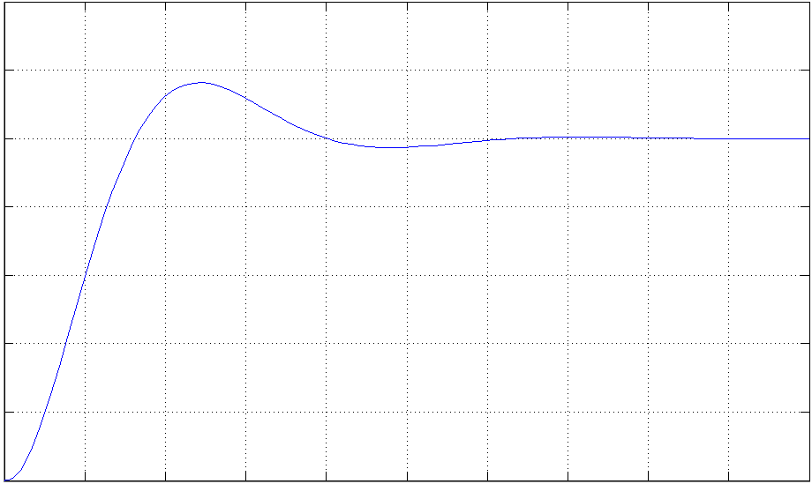
3.14 sec
Time

Find yss, ess to step, ymax, Mp, and the transfer function of the system.

- The forward-path transfer function of a unity-feedback control system is given as:
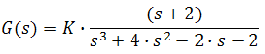
The root-locus diagram has been constructed for this system and is shown below.
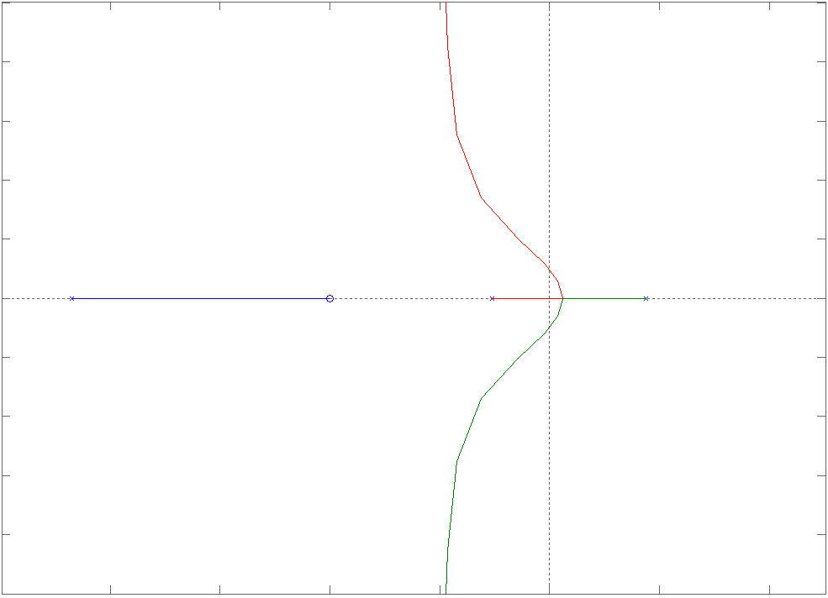
A
A*

Find the value of K at A/A*, and the value of A.

