EE 475 Fall 2006 Quiz #3
Name:

Consider the following signal flow graph:
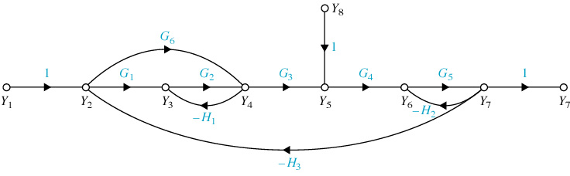
One forward path is M: Y1-1-Y2-G1-Y3-G2-Y4-G3-Y5-G4-Y6-G5-Y7-1-Y7
- Use the same style to name the other forward path from Y1 to Y7:
M1:
- The corresponding forward path gain is
- Name the forward path from Y8 to Y7:
M2:
- The corresponding forward path gain is
- Name one of the two loops involving only two nodes (start and end with a node):

- The corresponding loop gain is
- Name one big loop involving more than two nodes (start and end with a node):

- The corresponding loop gain is
- There is one pair of non-touching loops, their gain product is
- When you remove forward path M2, there is only one loop left, which is ;
- The corresponding Δ₂ associated with M₂ is Δ₂ = ;
- The corresponding Δ₁ associated with M₁ is Δ₁ = ;

