EE 475 Fall 2006 Quiz #3
Name:

Consider the following signal flow graph:
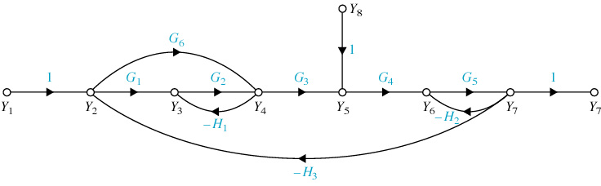
One forward path is M: Y1-1-Y2-G1-Y3-G2-Y4-G3-Y5-G4-Y6-G5-Y7-1-Y7
- Use the same style to name the other forward path from Y1 to Y7:
M1: Y1-1-Y2-G6-Y4-G3-Y5-G4-Y6-G5-Y7-1-Y7
- The corresponding forward path gain is G6G3G4G5
- Name the forward path from Y8 to Y7:
M2: Y8-1-Y5-G4-Y6-G5-Y7-1-Y7
- The corresponding forward path gain is G4G5
- Name one of the two loops involving only two nodes (start and end with a node):
Y3-G2-Y4-(-H1)-Y3 Y6-G5-Y7-(-H2)-Y6
- The corresponding loop gain is -H1G2 -H2G5
- Name one big loop involving more than two nodes (start and end with a node):
Y2-G1-Y3-G2-Y4-G3-Y5-G4-Y6-G5-Y7-(-H3)-Y2
- The corresponding loop gain is -G1G2G3G4G5H3
- There is one pair of non-touching loops, their gain product is H1H2G2G5
- When you remove forward path M2, there is only one loop left, which is -H1G2 ;
- The corresponding Δ₂ associated with M₂ is Δ₂ = 1+H1G2 ;
- The corresponding Δ₁ associated with M₁ is Δ₁ = 1 ;

