EE 475 Fall 2006 Quiz #4
Name:

Consider the following electric circuits:
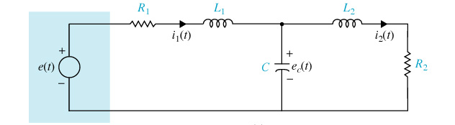
- How many state variables should be selected:
- The most natural choice of the state variables are:
- The order of the system model is:
- The A matrix of the state space model is a by matrix.
Now consider:
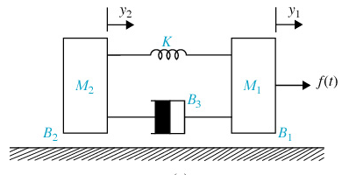
- Name the two elements that can store energy: and
- The two types of energy each element can store are and .
- How many state variables should be selected:
- The order of the system model is:

- Given: , y/x =
+
- Draw a signal flow graph for the block diagram in 9.

