EE 475 Fall 2006 Quiz #4
Name:

Consider the following electric circuits:
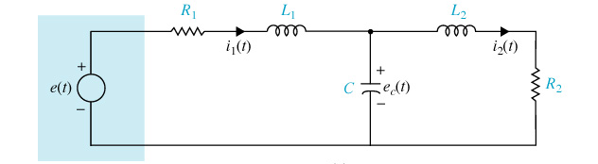
- How many state variables should be selected: 3
- The most natural choice of the state variables are: i1, i2, ec
- The order of the system model is: 3
- The A matrix of the state space model is a 3 by 3 matrix.
Now consider:
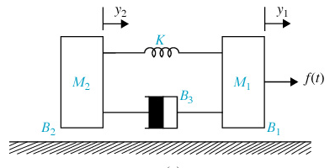
- Name the two elements that can store energy: mass (M1, M2) and spring(K)
- The two types of energy each element can store are potential energy ( ½ K(y1-y2)² and kinetic energy ( ½ M1y1dot^2, ½ M2 y2dot^2) .
- How many state variables should be selected: 4, or 3(minimum)
- The order of the system model is: = #state variables

- Given: , y/x = G1/(1-G1G2)
+
- Draw a signal flow graph for the block diagram in 9.
X e G1 y y
G2

