EE 475 Fall 2006 Quiz #8
Name:

The closed-loop step response of a system is given below. Mark, using lines and arrows, the following specs on the graph and write the numerical value by the marks: yss, ess, ymax, Mp(%), td, tr, ts, and tp. Tolerance band = 2%.
Bonus: system type= , K_{p}= , K_{v}= , K_{a}=

Consider the following system and assume that parameters are selected so that closed loop system is asymptotically stable.
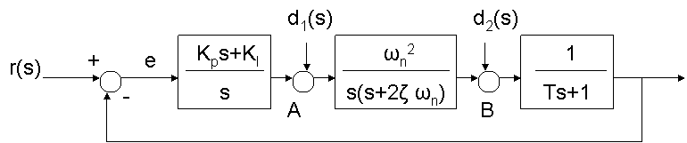
The system type with respect to r(s) = , K_{p}= ,K_{v}=
If r(s) = 1/s, d1=d2=0, the steady state value of e(t) =
If r(s) =t*u_{s}(t), d1=d2=0, the steady state value of e(t) =
The system type with respect to d1(s) =
If r(s) =0, d1=1/s, d2=0, the steady state value of e(t) =

