EE 475 Fall 2006 Quiz #8
Name:

The closed-loop step response of a system is given below. Mark, using lines and arrows, the following specs on the graph and write the numerical value by the marks: yss, ess, ymax, Mp(%), td, tr, ts, and tp. Tolerance band = 2%.
Bonus: system type= 0 , K_{p}= 9 , K_{v}= 0 , K_{a}= 0

yss=0.9

Consider the following system and assume that parameters are selected so that closed loop system is asymptotically stable.
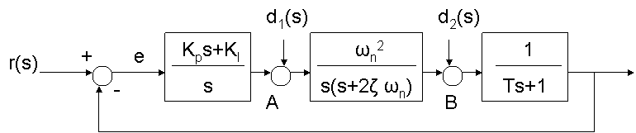
The system type with respect to r(s) = 2 , K_{p}= ∞ ,K_{v}= ∞
If r(s) = 1/s, d1=d2=0, the steady state value of e(t) = 0
If r(s) =t*u_{s}(t), d1=d2=0, the steady state value of e(t) = 0
The system type with respect to d1(s) = 1
If r(s) =0, d1=1/s, d2=0, the steady state value of e(t) = 0

