EE 475 Fall 2010 Midterm Exam #1
Name:

- Determine the number of roots of in the left half plane, on the jw-axis, and in the right half plane, by constructing the Routh table.

- Determine a region in the α ~ K plane that ensures stability of the characteristic polynomial .

- For the system block diagram given below, draw the corresponding signal flow graph.
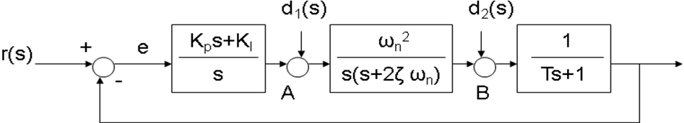y

- For the system given in the previous problem, find the transfer function from r to e and the transfer function from d1 to y. No need to simplify.

- For the system given in the previous problem, determine the system types with respect to r, to d1 and to d2 respectively.

- For the system given in the previous problem, if r is a unit acceleration signal and d2 is a unit ramp signal, and d1 is a unit step signal, what is the steady state error? Assume closed-loop system is stable.

- Consider the circuit below. Assume ideal op amps. Obtain the transfer function model of the system.

- For the liquid level system below, let x1=h1, x2=h2, u=qd, and y=qo. Derive the state space model for the system. Assume linear small signal models. The proportional controller is described by qi = –K*h2. Liquid head dynamics are described by Cdh/dt = net flow into tank.
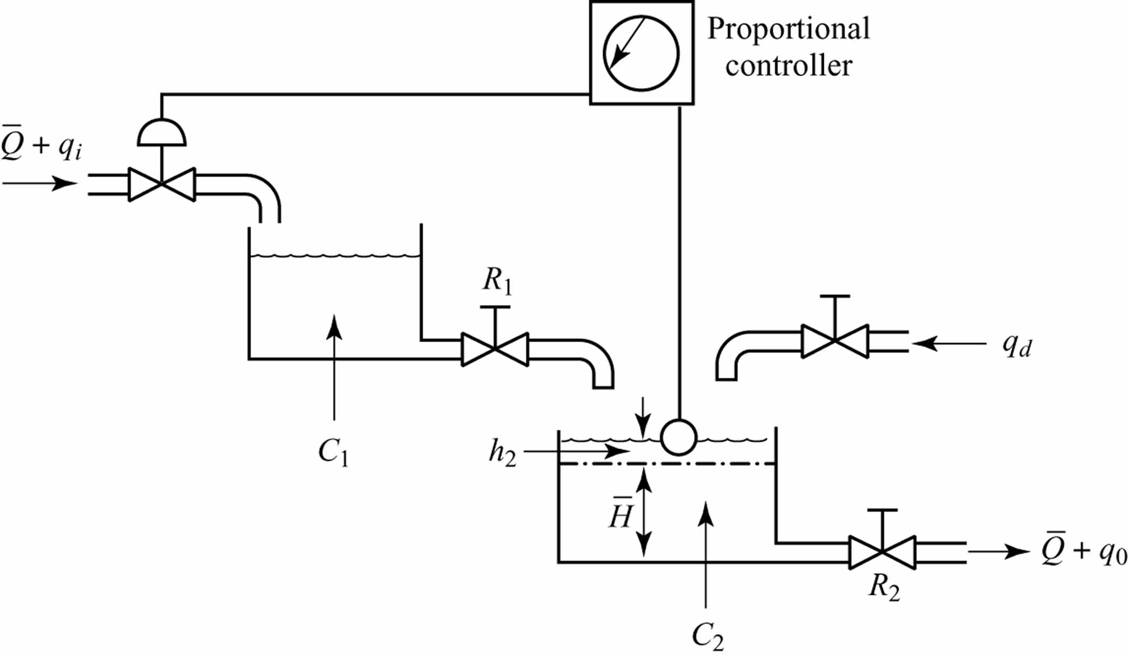

- For the system given below, determine K and k so that closed-loop step response will have about 5% overshoot and about 0.4 sec settling time (2% tolerance).
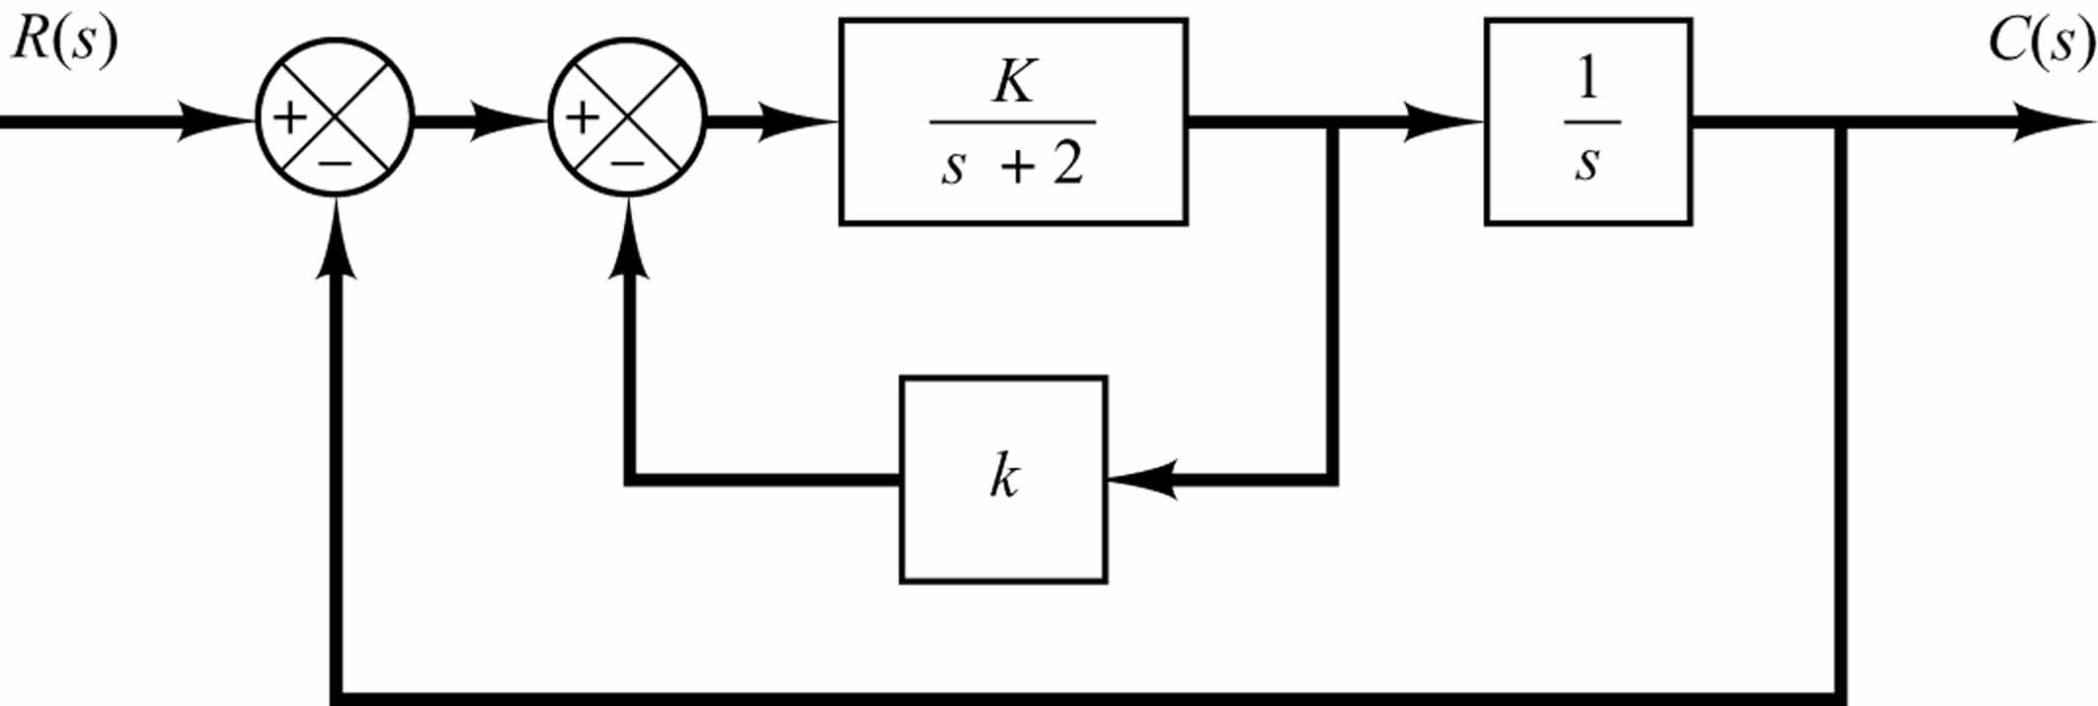

- A closed-loop control system has unit step response given below.
  - Is the system 1st order, 2nd order, or higher order?
  - Is the system type 0, type 1, or type 2?
  - Roughly sketch the unit impulse response.
