EE 475 Fall 2010 Midterm Exam #2
Name:

- Determine the number of roots of in the left half plane, on the jw-axis, and in the right half plane, by constructing the Routh table.

- For the system given below, design the PD controller C(s)=K_{P}+K_{D}s, so that the closed-loop pole pair has damping ratio = 0.5 and magnitude = 4. Determine the values of K_{P} and K_{D}.
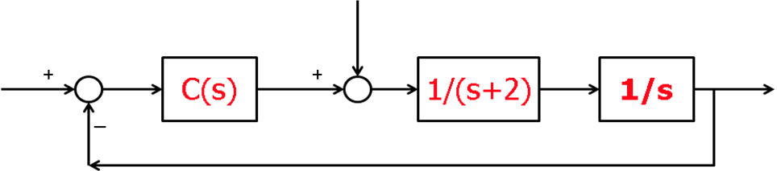

- For the system in problem 2, suppose a student decided to have KD=4 and KP=36. (these are the wrong answers for problem 2) Determine the system type with respect to reference input (at the left) and system type with respect to the disturbance input (at the top). Determine the ess when the reference input is a unit step, or unit ramp, or unit acceleration signal.

- Now suppose the student wants to implement the differential control partially in feedback and partially in feed forward, as bellow, where C’(s) = K_{P}+(b+KD)s. Show that the closed-loop poles are not affected. Select b so that the type with respect to reference input is increased to 2.
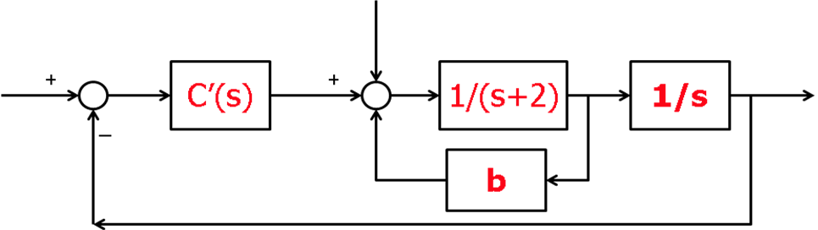

- A closed-loop control system has unit step response given below.
  - Is the system 1st order, 2nd order, or higher order?
  - Is the system type 0, type 1, or type 2?
  - Roughly sketch the unit impulse response.
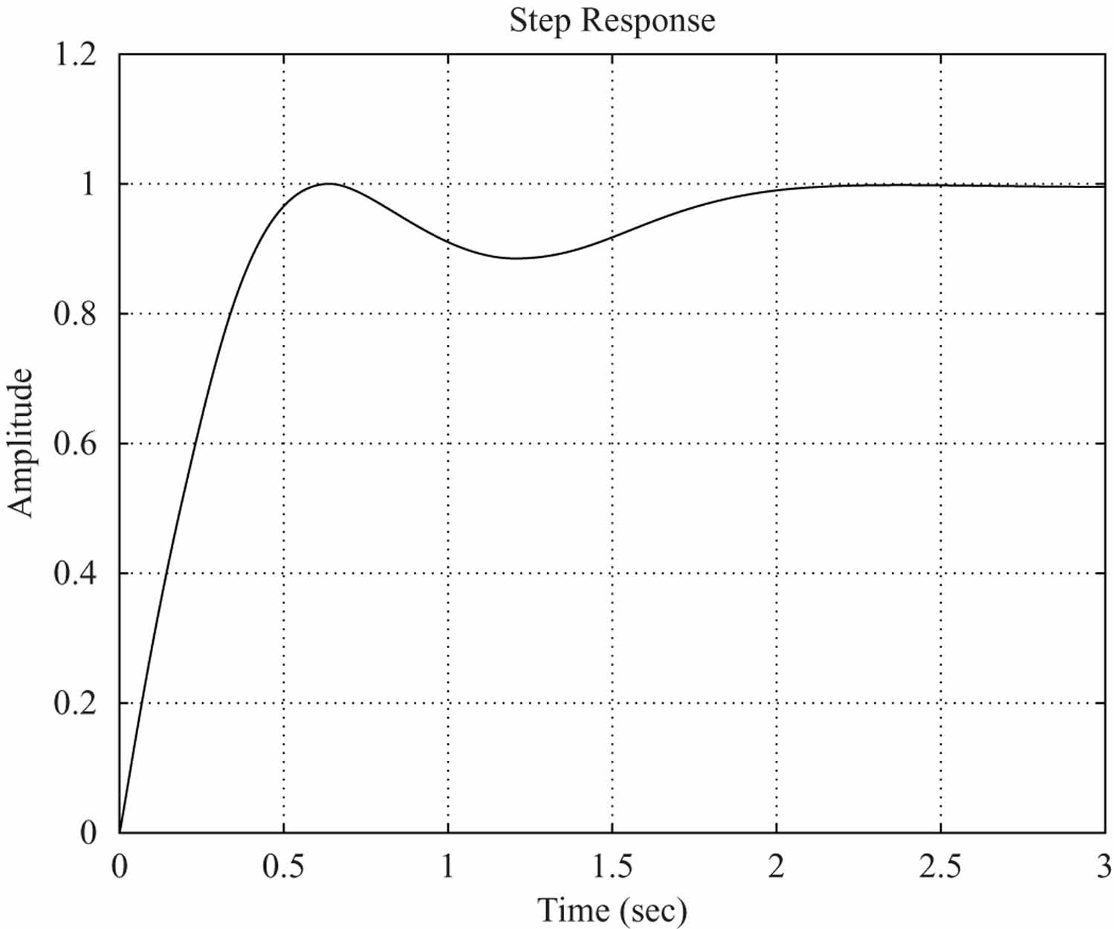

- Hand sketch the root locus for the system below, as K varies from 0 to +inf.
_
+
K
R(s)
Y(s)
E(s)

- In a Bode based lead controller design, suppose that w_gcd, PM_d, and G_wgcd have been determined. Write a few lines of Matlab code that a) determine the amount of phase lead the controller needs to contribute, b) compute the pole and zero of the lead controller, and c) compute the correct gain K for the lead controller.

- In a root locus based controller design, it has been decided that a lead controller is needed to place the dominant pole at a desired value p_d. The plant transfer function is defined in G. Write a few lines of Matlab code to a) find the angle deficiency of G at p_d, b) use the angle bisector method to find z_lead and p_lead, c) find the correct controller gain K to use.
- A unity gain feedback control system has a forward transfer function whose Bode plot is given below.
Estimate the percentage overshoot, peak time, rise time, settling time, and (ringing) oscillation frequency in the closed-loop unit step response. Estimate the -3 dB bandwidth in the closed-loop frequency response.
- The closed-loop bode plot of a negative unity feedback control system is given below.
Estimate the closed-loop bandwidth, resonance frequency, and resonance peak.
Estimate closed-loop step response overshoot Mp and rise time tr.

