Practice Questions for the Final Exam, Fall 2010

- Consider a linear control system given by the following state space model.
$\begin{aligned}\overset{˙}{x}=\left[\begin{matrix}−1 & 0 & 0 \\ 0 & −2 & 0 \\ 0 & 0 & −3\end{matrix}\right]x+\left[\begin{matrix}2 \\ 1 \\ 0\end{matrix}\right]u \\ y=\left[\begin{matrix} 1 & −1 & 1 \end{matrix}\right]x\end{aligned}$
Determine the characteristic values (eigenvalues) of the system. Determine if the system is BIBO stable. Justify.

- Without computing the controllability or observability matrices, determine the controllability and observability of the system given in problem 1. Justify.

- Given H(s) = (s-1)/{(s+2)(s2-1)}. Give a new 3rd order state space representation in CCF and another 3rd order one in OCF.
- Given $M(t)=\left[\begin{matrix}e^{t} & (e^{t}−e^{−t})/2 \\ 0 & e^{−t}\end{matrix}\right]$. Is M(t) a state transition matrix? If it is, find A such that M(t) = exp(At); if not, explain why not.
- Given A= [0 1; 2 3], B= [0; 1], C= [2 4], D= [0]. Find the Transfer function, determine if the system is completely controllable by computing the controllability matrix, and completely observable by computing the observability matrix.
- Determine if the following system is completely observable and/or completely controllable:
A= [2 0 0 0] B= [1] C=[1 0 2 4] D=[0]
[0 3 0 0] [2]
[0 0 -3 0] [5]
[0 0 0 1] [3]
- Determine if the following system is completely observable and/or completely controllable:
A= [1 1 0 0 0] B=[0 0] C= [1 2 3 4 5] D= [0 0]
[0 1 0 0 0] [0 1] [0 3 4 2 1] [0 0]
[0 0 2 1 0] [1 1]
[0 0 0 2 0] [1 0]
[0 0 0 0 1] [0 1]

- For the block diagram below, draw the equivalent signal flow graph using 5 nodes: input, output, and one node for each of the 3 junctions.

G1
G2
G3
H1
H2
H3
G4
- Find the input output transfer function for the system in problem above. Assume all + signs at the summing junctions
- Given the circuit below. u(t) is input and the voltage vo(t) is output. Use the capacitor voltages and inductor current as state variables. Derive the state space model for the circuit.
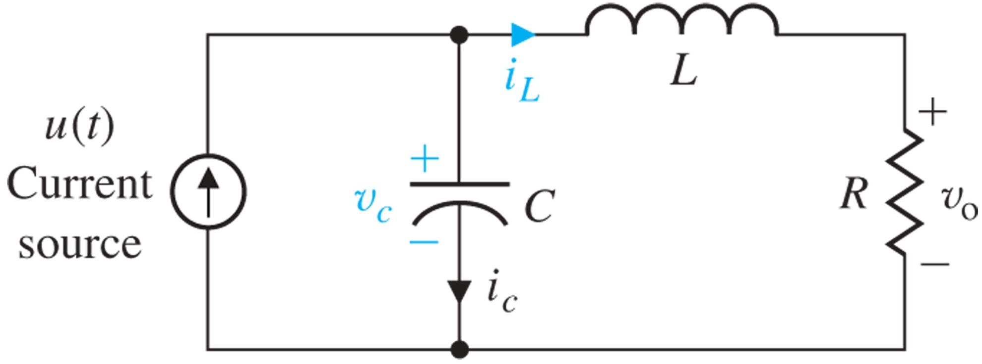
- The closed-loop unit step response of a stable control system has been obtained. Two column vectors t and y are available to you, which contain the time and output values of the step response. Write a few lines of Matlab code to determine if Overshoot exists and if it does find the percentage overshoot and the time at which maximum overshoot occurs.

- As in the previous problem, write a few lines of Matlab code to compute the rise time and settling time (2%tolerance) of the system.

- Write a few lines of Matlab code that will a) draw a circle corresponding to a rise time of <= 0.5 second, b) draw a cone corresponding to overshoot <= 16%, c) prompt the user to select a dominant pole in the desired region.

- A Bode plot of a system has been drawn. 15% of maximum overshoot is permitted. Write a few lines of Matlab code to a) determine the desired phase margin, b) draw a horizontal line in red color on the phase plot that corresponds to the desired phase margin, and c) prompt the user to use mouse to select a desired gain crossover frequency.

- In a root locus based controller design, it has been decided that a lead controller is needed to place the dominant pole at a desired value p_d. The plant transfer function is defined in G. Write a few lines of Matlab code to a) find the angle deficiency of G at p_d, b) use the angle bisector method to find z_lead and p_lead, and c) find the correct controller gain K to use.

- In a root locus based controller design, the plant TF is type 1 and is defined in G, a lead controller has been designed with z_lead, p_lead, and K computed. It has also been determined that a lag controller is needed to reduce the ess to ramp to <= ess2ramp_des. Write a few lines of Matlab code that will a) compute the ess2ramp when the lead controller is in place, 2) compute the parameters of the lag controller (z_lag, p_lag, K_lag).

- In a lead-lag controller design, suppose a lead controller and a lag controller have been designed. That is, G is defined, z_lead, p_lead, z_lag, p_lag, K_lead, and K_lag have been computed. Write a few lined of Matlab code that will a) compute and display the overall controller TF C, b) compute and display the overall closed-loop TF H, and compute and display the closed-loop unit step response.

- A negative unity gain feedback control system has been designed and stabilized. The closed-loop TF is defined in Gcl. Write a few lines of Matlab code to compute and display the time response of the tracking error when the reference input is a unit ramp or a unit acc signal.

- In a Bode plot based controller design, a proportional controller is needed to make sure that the closed loop step response overshoot is <= Mp_des %. The plant TF is defined in Gp. Write a few lines of Matlab code that will a) draw the Bode of Gp and also return magnitude, phase and frequency values, b) compute the desired phase margin with proper safety extra, c) find the frequency at which the phase of Gp is approximately what you want, and e) compute the desired value of K to make the frequency in c) your gain crossover frequency.

- In a Bode based lead controller design, suppose that w_gcd, PM_d, and G_wgcd have been determined. Write a few lines of Matlab code that a) determine the amount of phase lead the controller needs to contribute, b) compute the pole and zero of the lead controller, and c) compute the correct gain K for the lead controller.

- An LTI system has characteristic polynomial d(s) = s⁴ + 2Ks³ + (1+ K²)s² + 2Ks + K². A) find conditions on K such the system is asymptotically stable, B) find the value of K such that the system will have sustained oscillation, and C) find the oscillation frequency.

- The open loop Bode plot of a unity feedback system is given when a forward path gain K=1. The Bode plot has uniquely defined w_gc, w_ph, GM>0, and PM>0. Suppose you can continuously adjust the gain K. At what value of K will the system exhibit sustained oscillation? What frequency will it oscillate at?

- For the system in the previous problem and with the value of K you determined, if one constructs the Routh table for the closed loop denominator polynomial, what will happen? Is it possible to select a different value of K to make another row of the Routh table to be entirely zero?

- For the system in the previous two problems, if one draws the root locus of the open loop TF, at what value of K would the root locus cross the jw axis, where on the jw-axis would it cross, exactly how many times would it cross the jw axis? With

- Roughly hand sketch the root locus 1+ K(s+1)/(s²+4) = 0 as K = 0 to ∞.

- Roughly hand sketch the root locus 1 + K(s+1)/{(s+5)(s²+4)} = 0 as K = 0 to ∞.

- Consider a control system given in the following block diagram:
+
K
G(s)

_

where G(s) = 1/{s^2+2s+10)(s+4)(s+6.2)}. Sketch the root locus as K = 0 to ∞ and answer the following questions.
- What is a rough estimate of the break-away point?
- For what value of K will the closed-loop system admit sustained oscillation and at what frequency?
- What are the departure angles?

- For the system in the previous problem, what is the smallest overshoot that can be achieved with a proportional controller? With this controller, what is the ess to step? What is the settling time with +-2% tolerance?

- For the system in the previous problem, what is the smallest ess to step that can be achieved with a proportional controller? With this controller what is the Mp? What is the ts?

- Hand sketch the root locus 1+ K(s+1)/(s²+2s+2)² = 0 as K = 0 to ∞. How many asymptotes are there, at what angles, where do they meet? What are the departure angles?

- A closed-loop system has step response given below.
  - Is this system a prototype second order system?
  - This system has one zero, do you think it is in the left or right half plane?
  - Is the system BIBO stable or unstable?

- Base on the step response in the previous problem, estimate the following.
  - The rise time: .
  - The delay time: .
  - The peak time: .
  - The 2% settling time: .
  - The percentage overshoot: .

- In a unity feedback set-up, the open-loop transfer function G(s) is stable and minimum phase with all real coefficients. The Bode plot of G(s) given.
- Find the gain crossover frequency, phase crossover frequency, gain margin, and phase margin.
- Determine the closed loop stability.
- Determine the system type and estimate the steady state tracking error in the closed loop unit ramp response.
- If the overall system gain is increase by 10 times, what happens to the closed- loop stability?

- A unity gain feedback control system has a forward transfer function whose Bode plot is given below.
  - What is the gain and phase cross over frequency, gain margin, phase margin?
  - Is the closed-loop system stable?
  - If the controller gain is to be adjusted, by how much can it be increased without losing closed-loop stability? By how much can the gain be reduced?
  - If the actuator causes a pure time delay, how much delay can be tolerated?
  - What is the system type, what are the position, velocity, and acceleration error constants?
  - What would be the steady state tracking error if a unit step, or unit ramp, or unit acceleration input is applied?
  - Estimate the percentage overshoot, peak time, rise time, settling time, and (ringing) oscillation frequency in the closed-loop unit step response.
  - Estimate the dominant pole pair in the closed-loop system.
  - Estimate the DC value, -3 dB bandwidth, resonance frequency, and resonance peak in the closed-loop frequency response.

- Circle all polynomials that are Hurwitz, i.e., have all roots in the open left half plane.
- $$s^{3}+3s^{2}+5s+\text{10}$$
- $$−s^{3}+3s^{2}+5s−\text{10}$$
- $$s^{3}+2s^{2}+5s+\text{10}$$
- $$3s^{2}+\text{10}$$
- $$3s^{2}+5s+\text{10}$$
- $$s^{5}+3s^{2}+5s+\text{10}$$
- $$(s^{2}+1)(s^{3}+3s^{2}+5s+\text{10})$$
- $$(s+1)^{2}(s^{3}+3s^{2}+5s+\text{10})$$
- $$(s+1)^{2}(s^{2}+5s+\text{10})s$$
- $$−s^{2}−5s−\text{10}$$

- Some controllers’ frequency response plots are given below (either amplitude plot or phase plot). Label each plot with either PI, or PD, or Lead, or Lag.

- An LTI system has characteristic polynomial d(s) = s⁴ + s³ + Ks² + As + (K-A)K².
  - Construct the Routh table.
  - Find conditions on K and A for asymptotically stability. (3pts)
  - Graph the condition in the K~A plane. (2pts)

- Hand sketch the root locus of 1+ K(s+8)/(s³+11s²+10s) = 0 as K = 0 to ∞.
  - Mark the poles and zeros appropriately. (2pt)
  - Describe the real axis. (2pt)
  - Describe the asymptotes. (3pts)
  - Estimate the break-away point. (1pt)
  - Determine any the jw-axis crossing points. (1pt)

- Five unity feedback control systems’ open-loop Bode plots, closed-loop Bode plots, and closed-loop step response plots are given. Match each system’s plots by placing A, B, C, or D on the closed-loop Bode and step response plots. (8pts)

- Consider the block diagram below.
  - Draw the corresponding signal flow diagram. Make sure all the indicated variables are represented and all nodes and gains are properly marked.
  - Use Mason’s rule to find the transfer function from R to Y. Make sure you specify all forward paths, loop, non-touching loops, etc.

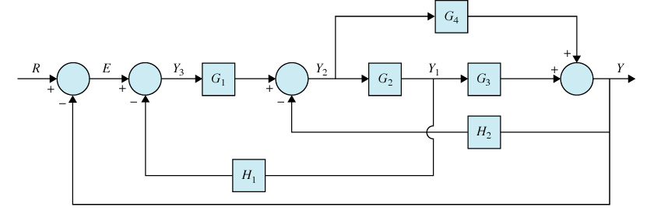

- A unity gain feedback control system has open-loop bode plot at shown below.
  - The system type is
  - Position error constant Kp =
  - Velosity error constant Kv =
  - Acceleration error Constant =
  - Steady state error due to a unit step input is
  - Steady state error due to a unit ramp input is
  - Steady state error due to a unit acceleration input is
  - The gain cross over frequency is rad/sec
  - The phase cross over frequency is rad/sec
  - The gain margin is dB
  - The phase margin is degrees
  - The closed-loop stability is
  - The closed-loop dominant pole has damping ratio ≈
  - The closed-loop step response will have overshoot ≈
  - The closed-loop bandwidth is approximately =
  - The closed-loop resonance frequency is approximately =
  - The closed-loop resonance peak Mr is approximately =
  - The closed-loop step response will have rise time ≈
  - The closed-loop step response will have settling time ≈
  - What controllers can be used to improve the overshoot , ,
  - If C(s)=K(s+z)/(s+p) is used, we should have z p and z*p=

