EE 475 Fall 2011 Quiz #1
Name:

- 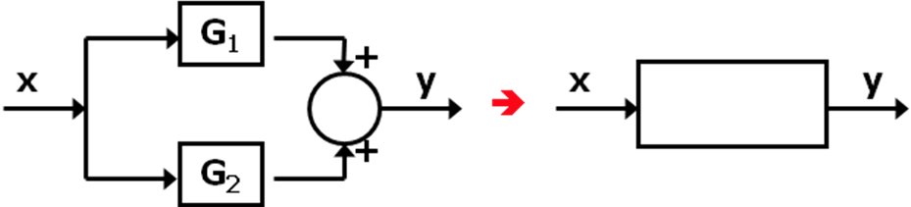
- 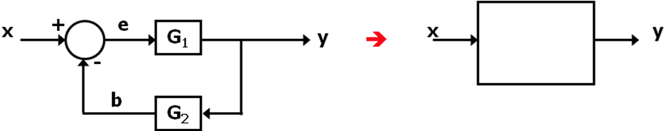
- 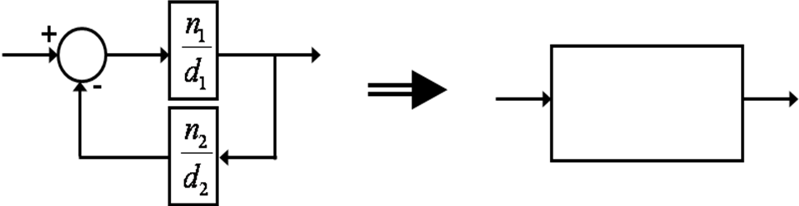
- 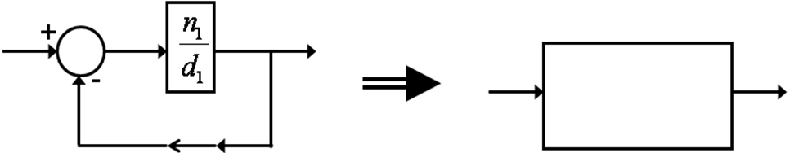
- Use block diagram simplification to find the transfer function from U to Y:
