EE 475 Fall 2011 Quiz #2
Name:

- For the signal flow graph below
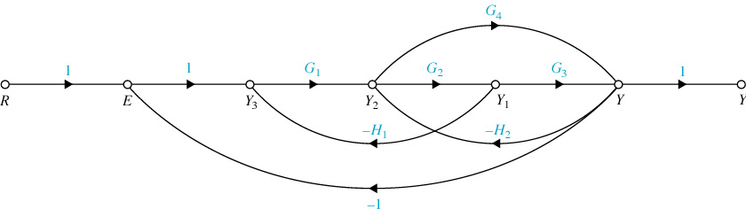
- List the forward paths from R to Y and their gains: .
- Find the determinant for each forward path: .
- List the loop gains: .
- List the non-touching loop pair’s gain product: .
- The determinant of the graph is Δ= .
- The transfer function from R to Y = .

