EE 475 Fall 2011 Quiz #3
Name:

- For an ideal op amp, its =0, =0, =0, =∞, and =∞.
- Consider the electric circuit given below.
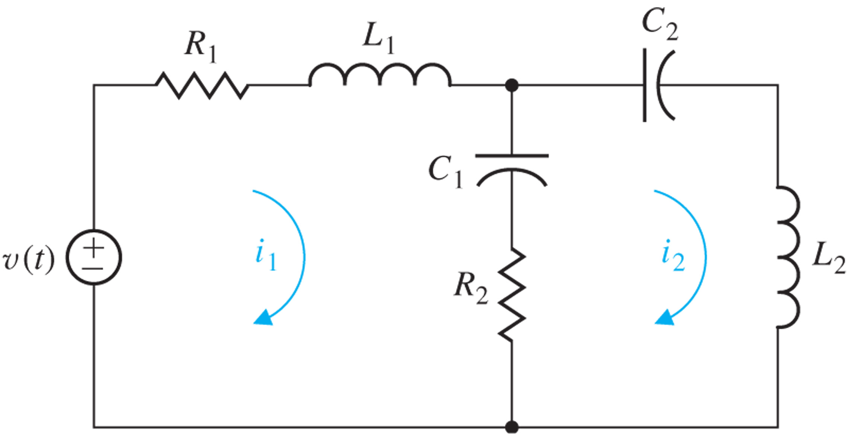
Express the following quantities in terms of v, i_{L1}, i_{L2}, v_{C1}, and v_{C2}.
- i_{R1}= i_{R2}=
- v_{L1}= v_{L2}= .
- Write the KCL at the node above C₁:

- Write the KVL along the loop i₁:

