EE 475 Fall 2011 HW #2
Due: 9/7/2011

- The book derived the transfer function of the PID controller given in Table 3-1 on page 85. Use this result to obtain the results given in item 3 and item 4 in the same table.
- Derive the e_{i} to e_{o} transfer function for the Lag-lead controller given in item 7 of Table 3-1. Assume ideal op amps.
- For the op amp circuit given below, vi is input, vo and vo1 are outputs, vc1 and vc2 are state variables. Derive the state space model for the circuit.

- B-3-4
- B-3-6
- B-3-8 Obtain state space model with e_{i} as input and e_{o} as output, and TF from e_{i} to e_{o}.
- B-3-13
- An armature controlled DC motor is shown below. Use google or Wikipedia for help if necessary. Show that the transfer function given is correct. K_{m} is the motor torque constant and K_{b} is the back emf constant.
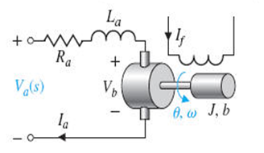

- For the electric circuit given below. Use v as input, i₁ and i₂ as output, and your choice of state variables to derive a state space model for the circuit. Get the transfer function from v to i₂.
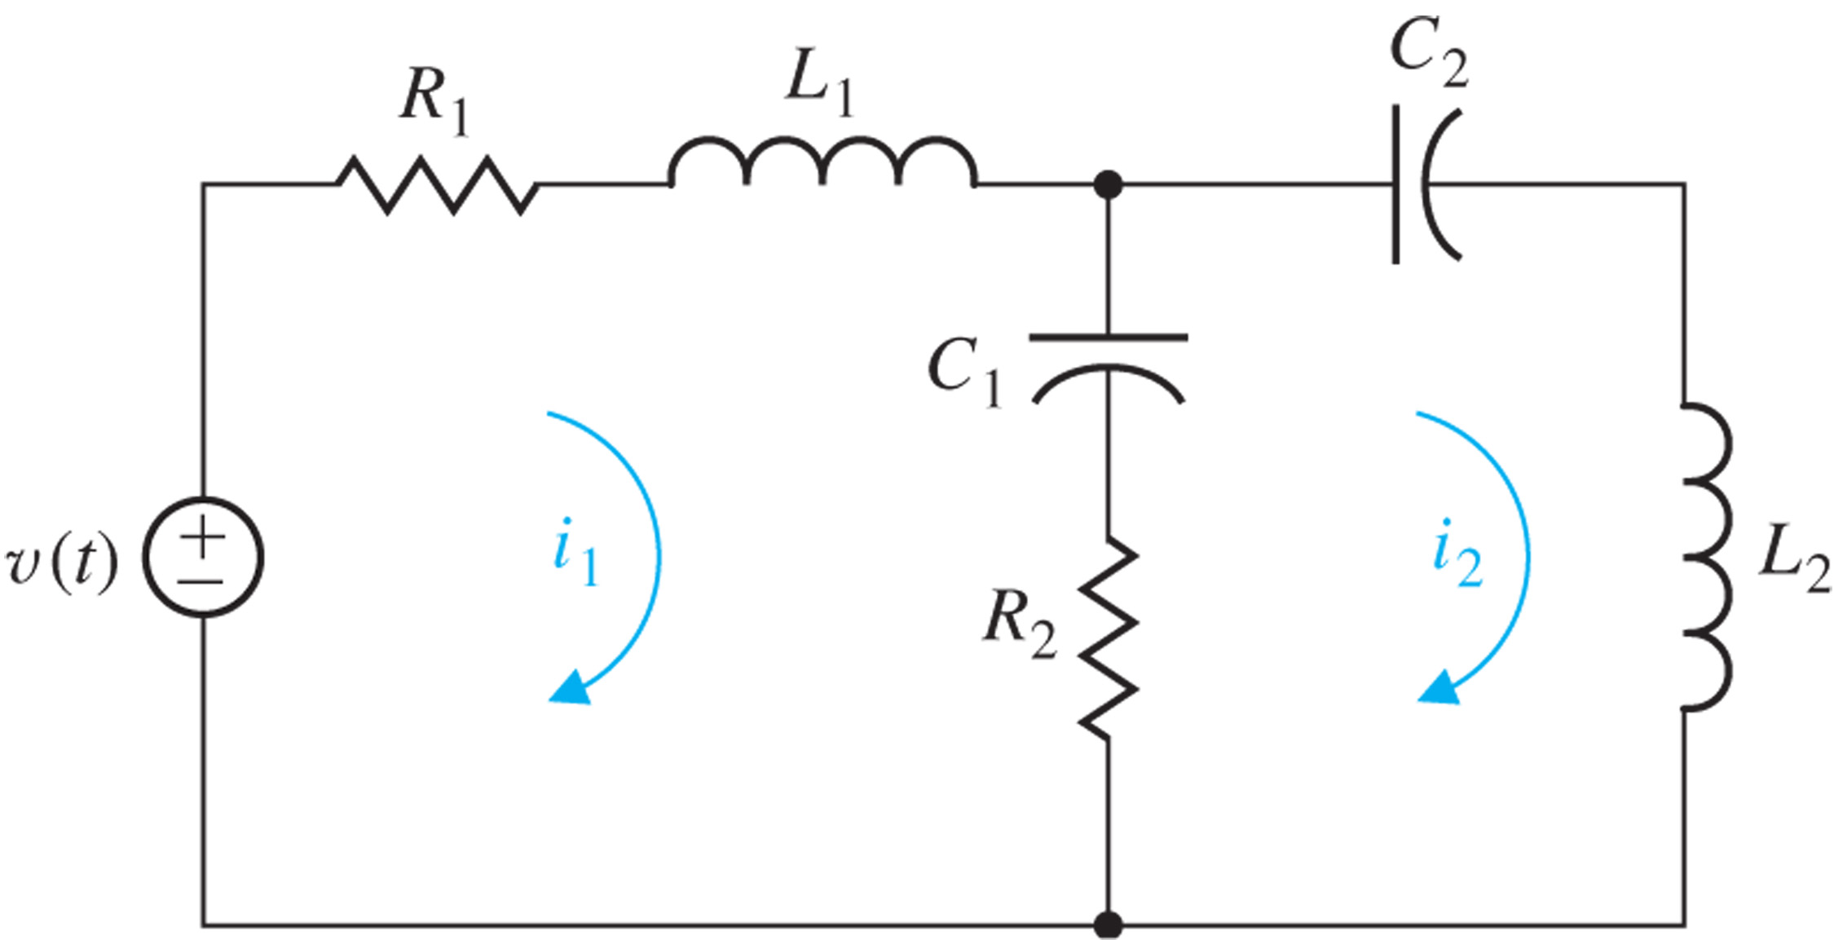

- A CMOS low noise amplifier that is typically used in your cell phone is given below in the left half of the graph. A simplified small signal circuit is represented in the right half of the graph. V_{s} is input and V_{o} is output. 1) How many energy storing elements are there? 2) Find the dependent relationships among the inductor currents and capacitor voltage. 3) Determine the minimum number of independent state variables needed. 4) Use these state variables to derive a state apace model for the low noise amplifier.
