EE 475 Fall 2011 HW #5
Due: 9/28/2011

- In problem 2 of HW4, you wrote a Matlab script file. Now add two more components to that program. After you have obtained your open loop TF and closed-loop TF, a) determined the system type, compute the corresponding error constant (if type=0, compute Kp, if type =1, compute Kv, if type=2, compute Ka), and compute ess to step, ramp, or acc input; b) compute the closed-loop poles, determine closed-loop stability, and the dominant pole’s damping ratio.
- B-5-20
- B-5-21
- B-5-22
- B-5-24
- B-5-26
- The motor speed control problem that you studied in HW3 is shown as the block diagram below. Only small signal model is represented. A PI controller is used. Kt=1 is assumed. The differential op amp, the PI op amp and the power amp are combined into a single PI controller block. Determine the system type with respect to Vin and the type with respect to Td. What kind of reference input Vin (step, ramp, or acc) can the system track with zero steady state error, or with finite error, or not at all. What kind of disturbance Td can the system reject with zero steady state error, or with finite error? Assume that the controller is designed in such a way that the closed-loop system is stable.
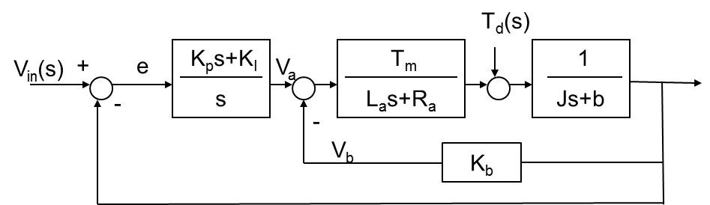

- Obtain the closed-loop characteristic polynomial for the system in the previous problem. Assume all parameters (La, Ra, Km, Kb, J, b) are positive. Use Routh criteria to find conditions on KP and KI so that the closed-loop system is asymptotically stable. (Can you show that you are guaranteed to have valid solution?) You can set Td=0 in this problem.
- The motor position control problem that you studied in HW3 is given by the block diagram below. Re-answer the questions in problem 8. Assume that the controller is designed in such a way that the closed-loop system is stable.
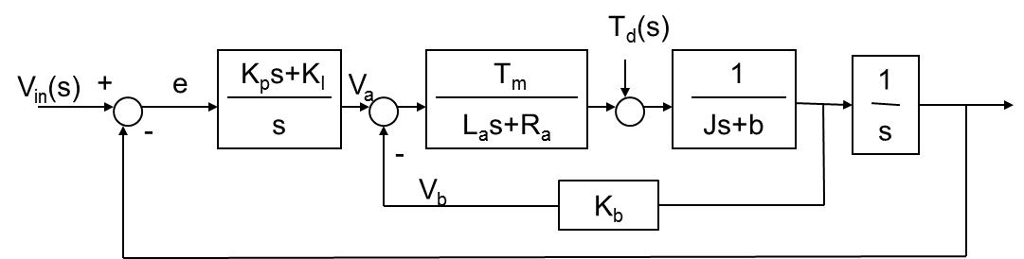

- Obtain the closed-loop characteristic polynomial for the system in the previous problem. Assume all parameters (La, Ra, Km, Kb, J, b) are positive. Use Routh criteria to find conditions on KP and KI so that the closed-loop system is asymptotically stable. (Can you show that you are not guaranteed to have valid solution? But if you can change Kb, you are guaranteed to have valid solutions.) You can set Td=0 in this problem.

