EE 475 HW #1
- With whatever help you can find from whichever source you prefer, briefly describe how a real closed-loop control system work. Draw a block diagram for the control system. Be sure to have a reference input, controller, plant, output, disturbance, feedback, error generator, and so on.
- Consider a system described by an ordinary differential equation:
  - Find the transfer function from input u to output y, its poles and zeros.
  - Give a state space model for the system, using y, and as state variables, u as input, and y as output.
  - Use Matlab to verify that your answers in a and b agree. Specifically, enter the state space model from b into Matlab, and ask Matlab to obtain the transfer function for the model.
- Do B-2-11 first by hand, and then use Matlab to verify your answer.
- B-2-2
- B-2-3
- B-2-4. Provide a 2-column (e is step, e is ramp) 5-row table (one for each controller). Each entry of the table is a hand sketch of the corresponding u(t).
- B-2-7
- For the signal flow graph given below, find the transfer function from Y1 to Y6 and from Y7 to Y6. 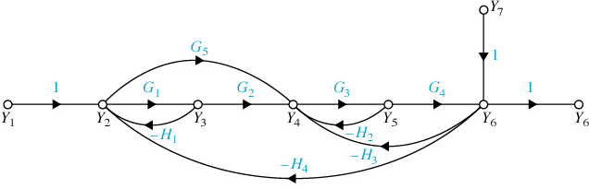
- For the block diagram given below, use Mason’s gain formula to find the transfer function from R to Y and from N to Y. 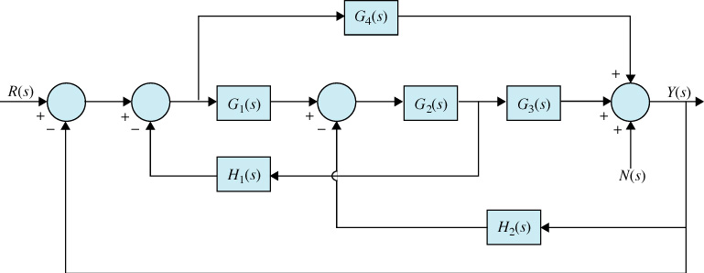
- Amotor control system is represented by the following block diagram. Find the transfer function from θ_{r} to θ_{o}. 