EE 475 HW #2
- The book derived the transfer function of the PID controller given in Table 3-1 on page 85. Use this result to obtain the results given in item 3 and item 4 in the same table.
- Derive the e_{i} to e_{o} transfer function for the Lag-lead controller given in item 7 of Table 3-1. Assume ideal op amps.
- For the op amp circuit given below, vi is input, vo is output, vc1 and vc2 are state variables. Derive the state space model for the circuit.
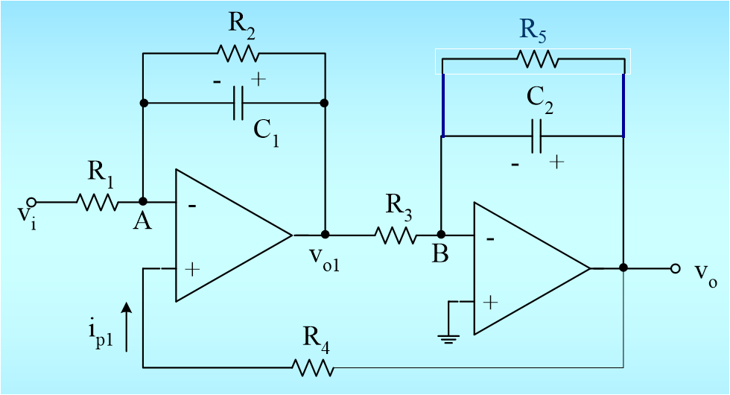
- B-3-7
- B-3-9
- B-3-11
- B-3-12
- B-3-13, take gear ratio = 1
- For the electric circuit given below. Use v as input, i₁ and i₂ as output, and your choice of state variables to derive a state space model for the circuit. Get the transfer function from v to i₂.
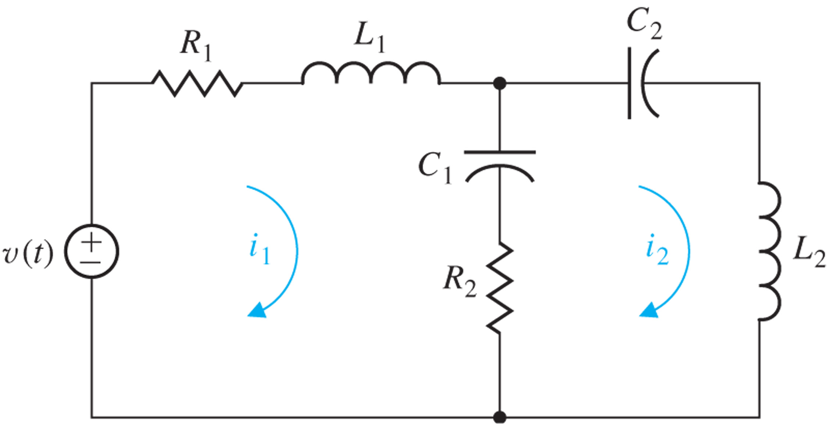

- A CMOS low noise amplifier (LNA) that is typically used in your cell phone is given below in the left half of the graph. There is also an R_{L} connecting from Vo to ground not shown. A simplified small signal circuit for the LNA is represented in the right half of the graph. V_{s} is input and V_{o} is output. 1) Identify the energy-storing elements. 2) Determine the state variables, the node to write KCL and the loops to write KVL. 3) Derive a state apace model for the low noise amplifier together with the load R_{L}.
