EE 475 HW #4
- In HW03 problem 2, you wrote a Matlab script file. Now you will add to that program.
  - In the part you entered step response specs, provide the option to enter steady state tracking specifications such as ess to step, ess to ramp, and ess to acceleration.
  - After you have entered the desired step response specifications, such as desired settling time tsd, desired overshoot Mpd, desired rise time trd, and so on, compute the desired values for zeta_d, omega_nd, sigma_d, omega_dd, and the desired closed-loop dominant pole pd = - sigma_d + j * omega_dd.
  - After the location where you computed your open and closed-loop TFs, compute the closed loop poles and determine if the closed-loop system is BIBO stable. Also identify the dominant pole pair.
  - After last step, determine the system type, compute the corresponding error constant (if type=0, compute Kp, if type =1, compute Kv, if type=2, compute Ka), and compute ess to step, ramp, or acc input.
- B-5-21
- B-5-22
- B-5-24
- B-5-26
- B-5-13
- A motor speed control problem is shown as the block diagram below. Only small signal model is represented. A PI controller is used. Determine the system type with respect to Vin. What kind of reference input Vin (step, ramp, or acc) can the system track with zero steady state error, or with finite error, or not at all. Assume that the controller is designed in such a way that the closed-loop system is stable. Set Td = 0.
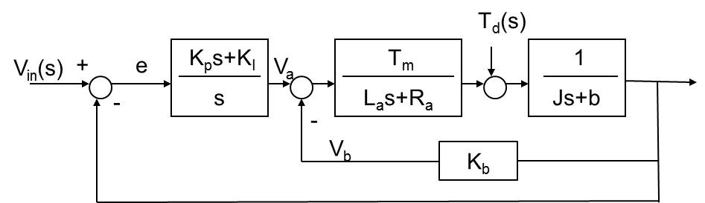

- Obtain the closed-loop characteristic polynomial for the system in the previous problem. Assume all parameters (La, Ra, Km, Kb, J, b) are positive. Use Routh criteria to find conditions on KP and KI so that the closed-loop system is asymptotically stable. You can set Td=0 in this problem.
- The motor position control problem is given by the block diagram below. Re-answer the questions in problem 7. Assume that the controller is designed in such a way that the closed-loop system is stable.
