EE 475 HW #5
- Make further modifications to your Matlab script file.
  - In actual control system designs, the design specifications will be given as either an inequality or as a range. For example, settling time can be either “settling time be less than a given tsd” or “settling time lie between tsd1 and tsd2”; overshoot specifications could be given as either “overshoot be less than a given Mpd” or “overshoot must be between Mpd1 and Mpd2”. Consequently, the computed desired values for zeta_d, omega_nd, sigma_d, omega_dd, are all either one sided or two sided inequality requirements. Now, plot these requirements in the complex plane. For example, “sigma >= sigma_d” is a half plane to the left of the vertical line at s=-sigma_d; “omega_n >= omega_nd” is the region outside the circle centered at the origin and having radius omega_nd; “zeta > zeta_d” is the conic region around the negative real axis with two rays starting at the origin with an angle cos⁻¹(zeta_d) with the negative real axis; “omega_d >= omega_dd” are the regions above the horizontal line at s=j*omega_dd and below the horizontal line at s=j*omega_dd. The desired closed-loop dominant pole pd must lie in the intersection of all these desired regions.
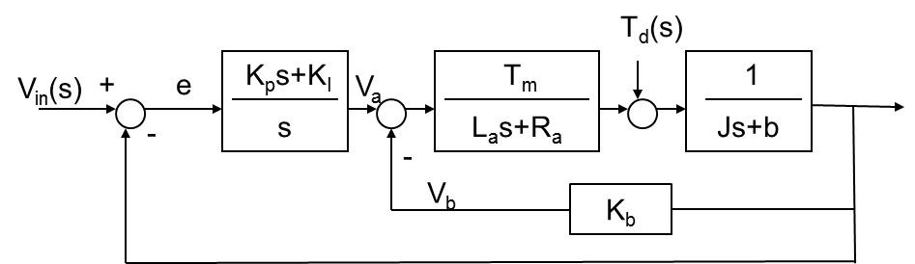
- A motor speed control problem is shown as the block diagram below. Only small signal model is represented. A PI controller is used. Assume all parameters (La, Ra, Km, Kb, J, b) are positive. Obtain the closed-loop characteristic equation. Rearrange the equation into a standard root-locus equation when K_{P} is a preselected positive constant and KI is being varied fom 0 to +∞.
- Redo the above if K_{I} is a preselected positive constant, but K_{P} is varying from 0 to +∞.
- B-5-9
- B-5-27
- B-6-6
- B-6-7

