EE 475 Quiz #4
Name:

- The time domain specifications of a control system is defined for the open / closed (circle the correct answer) loop system, with the initial conditions set at , and an external input being .
- The closed-loop unit step response of a system is given below. Find the following time-domain specifications, and mark them on the graph also.
  - yss =
  - ess =
  - ts =
  - tp =
  - tr =
  - td =
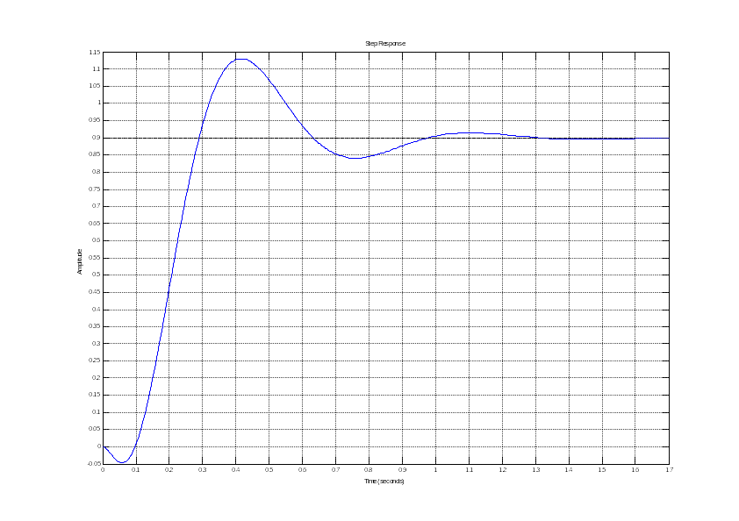
  - Mp =

